

**Multi-Region Application**

**Homework #4**

March 2022



Data 228 - Big Data Technologies and Applications

Department of Applied Data Science

San Jose State University

***Faiza Ayoun (015960139)***

***Harsimran Kaur (016003468)***

***Pooja Malage (015294760)***

***Saranya Pandiaraj (015304497)***

Table of Contents

**1. Create AWS Cloud9 Environment** **4**

**2. Build an API layer** **6**

1. Create an S3 bucket to store the app code 6

2. Package up the API code and push to S3 6

3. Deploy a stack of resources 7

**3. Build a UI layer** **9**

1. Create the AWS Cognito Identity Pool, S3 bucket and Cloudfront distribution 9

2. Configure Federated Identities with Cognito 11

3. Configure and build the application code 13

4. Upload the application 16

**4. Route53** **17**

1. Configure Route53 Domain 17

2. Configure ACM and Custom Domains in API Gateway 18

3. Configure Route53 DNS records 23

4. Update your UI with new API Gateway Endpoint 28

**5. Test failover** **29**

Testing Multi-region Active-active 29

Breaking the primary region 29

Deploying the API to prod stage 30

Verifying the failure for Ireland 30

Verifying the failure for Singapore 31

Creating First Ticket for the Singapore being unhealthy and assigning to EngHwa 32

Verifying the failure for Ireland Again 32

Creating Second Ticket for the Ireland being unhealthy and assigning to Jay 33

**7. S3 Replication and CloudFront with Multi-Region S3 Origins** **35**

1.Enable versioning on your source bucket in Ireland region 35

2.Create a destination bucket and enable versioning on it 35

3.Create an IAM role 36

Test CloudFront Failover **39**

References **40**

**Build a Multi-Region Serverless Application for Resilience and High Availability**

* <https://github.com/enghwa/MultiRegion-Serverless-Workshop>

# 1. Create AWS Cloud9 Environment

**Creating AWS Cloud9 Environment**

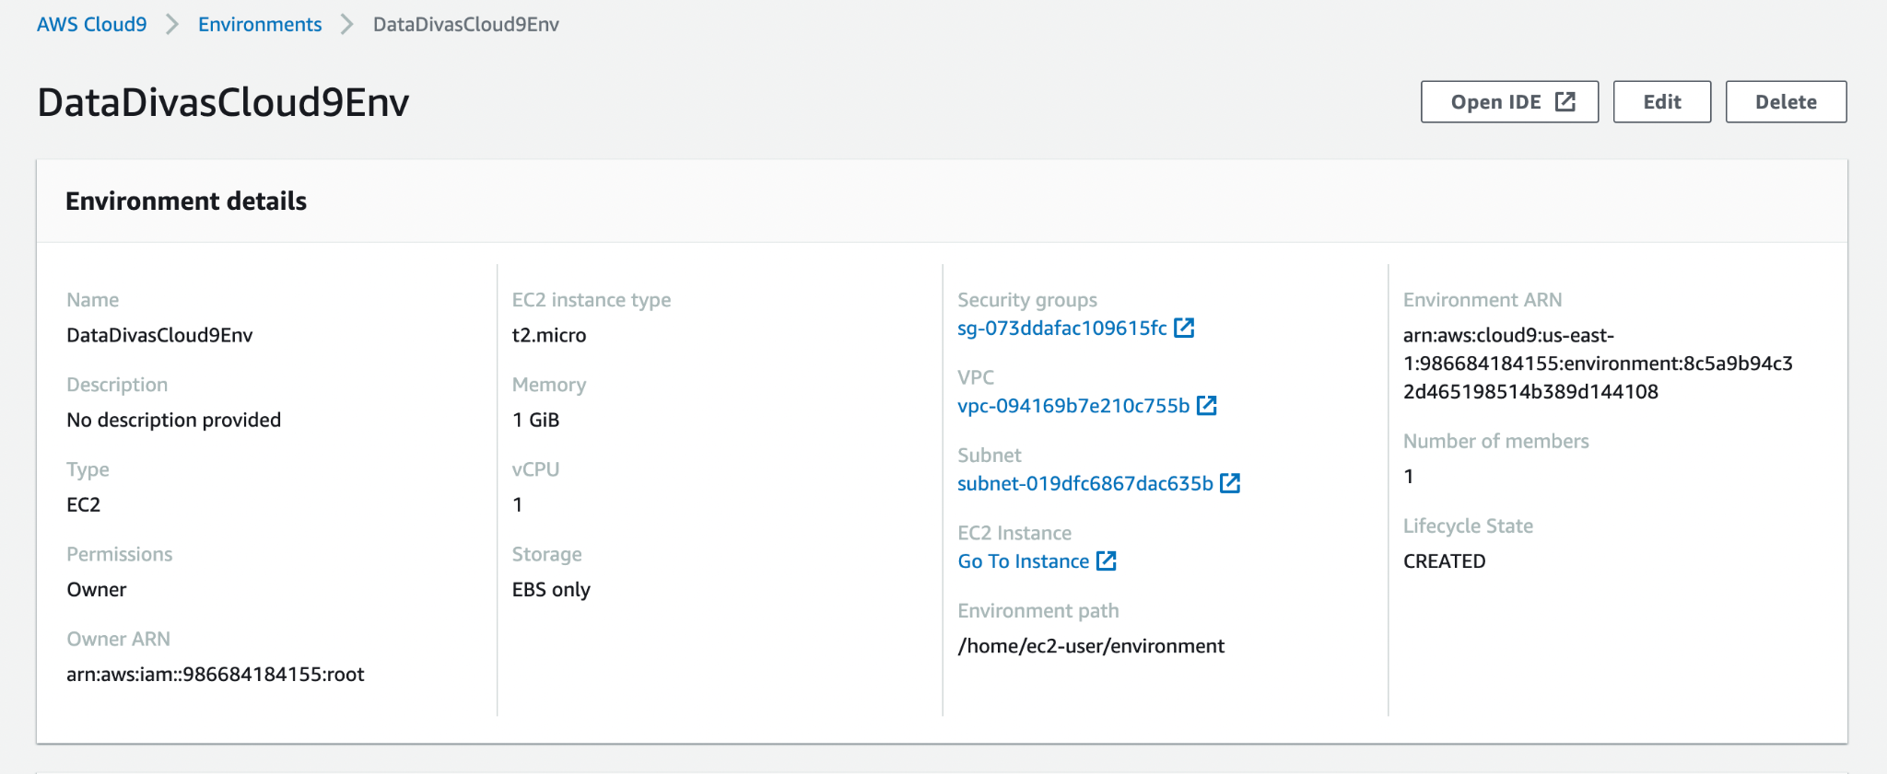

**Executing the shell commands in Cloud9**

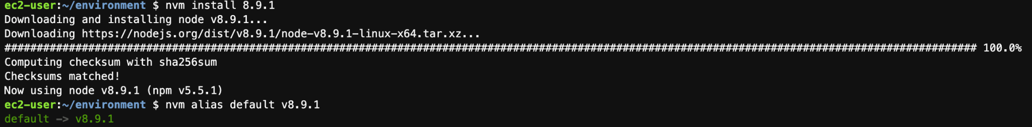

**Verifying right node and npm**

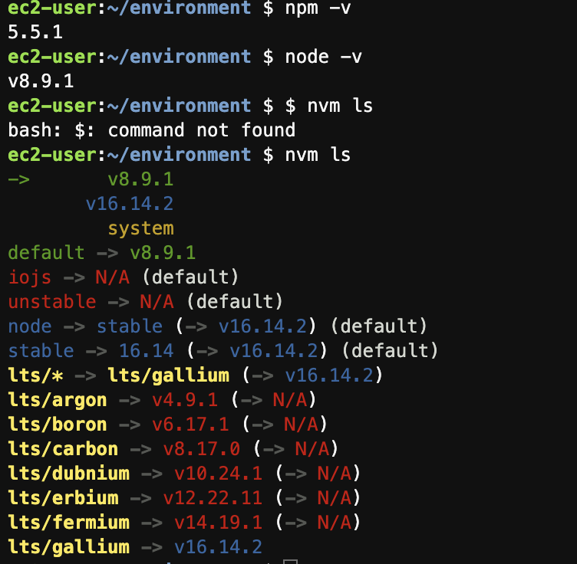

**Cloning the Workshop Project**

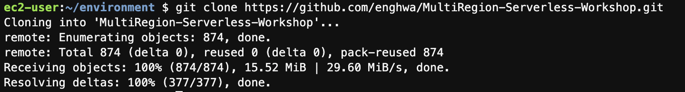

# 2. Build an API layer

**Using CLI Method**

## 1. Create an S3 bucket to store the app code

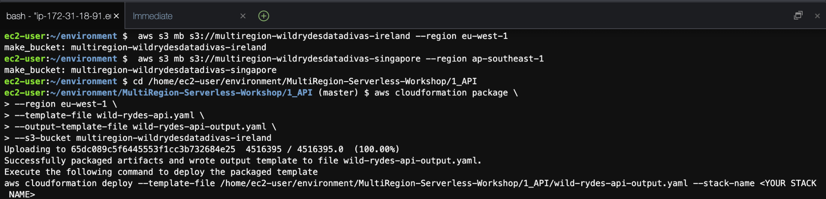

## 2. Package up the API code and push to S3

**Ireland(eu-west-1)**

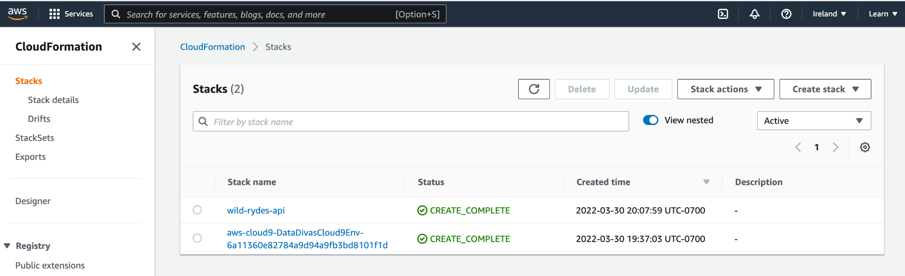

**Singapore(ap-southeast-1)**

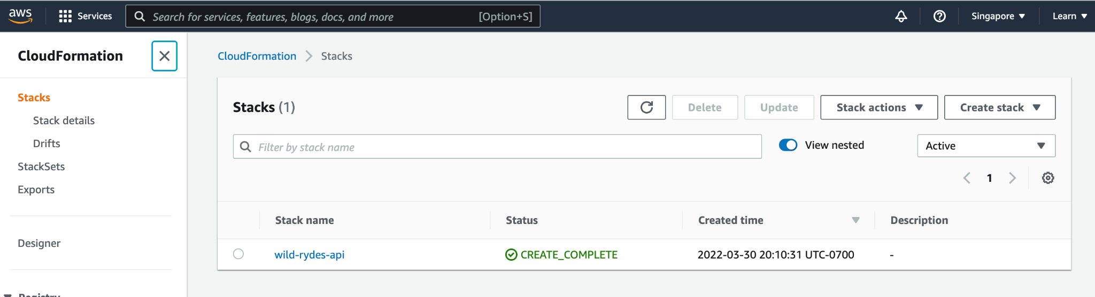

## 3. Deploy a stack of resources

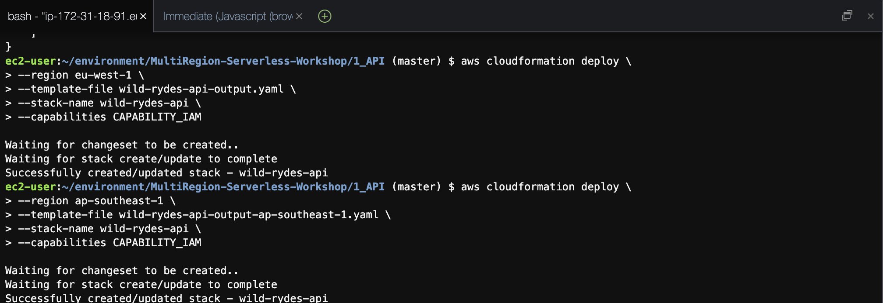

Confirming that API is working by copying the API URL for /ticket

**Ireland(eu-west-1)**

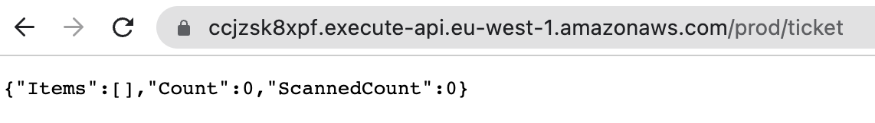

**Singapore(ap-southeast-1)**

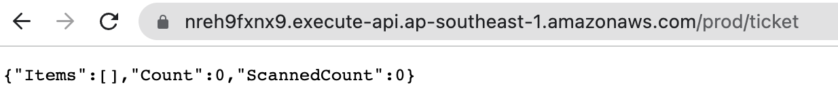

Confirming that API is working by copying the API URL for /health

**Ireland(eu-west-1)**

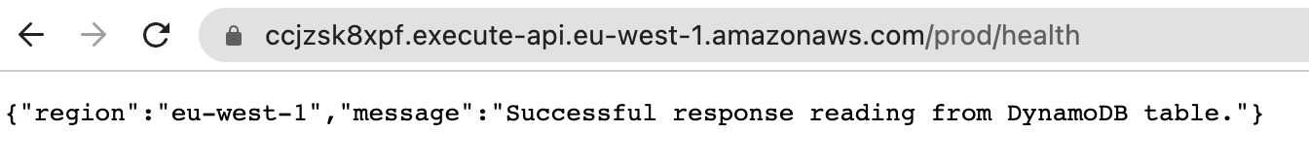

**Singapore(ap-southeast-1)**

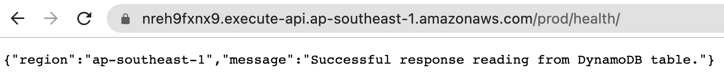

Enable DynamoDB Global Table using CLI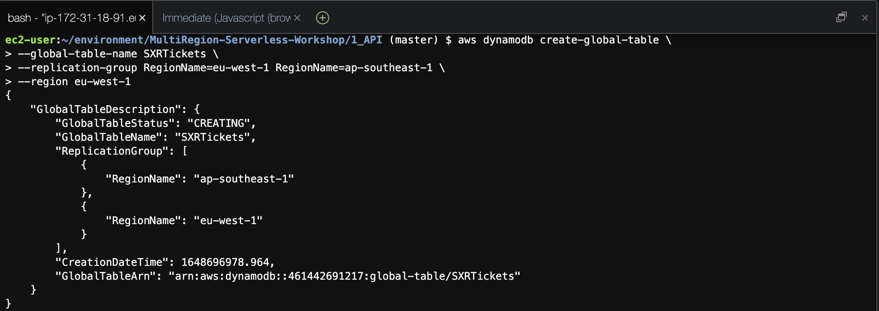

# 3. Build a UI layer

## 1. Create the AWS Cognito Identity Pool, S3 bucket and Cloudfront distribution

**AWS CloudFormation Deploy in eu-west-1 (Ireland)**

**aws cloudformation deploy \**

**--region eu-west-1 \**

**--template-file web-ui-stack.yaml \**

**--stack-name ticket-service-ui \**

**--capabilities CAPABILITY_IAM**

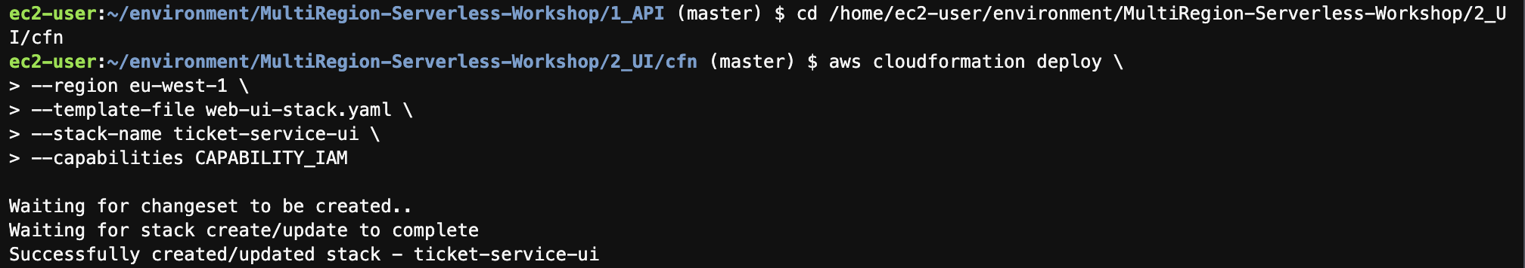

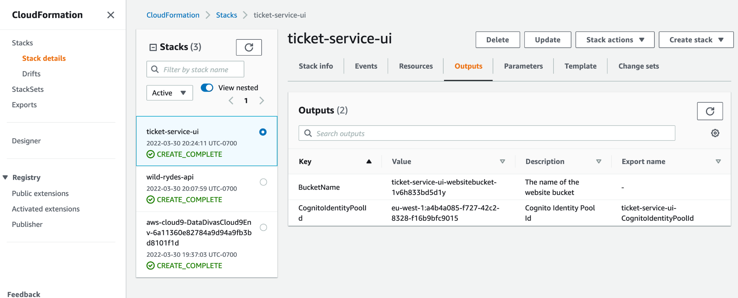

**CognitoIdentitiyPoolID Value:**

eu-west-1:a4b4a085-f727-42c2-8328-f16b9bfc9015

**BucketName** **Value**:

Ticket-service-ui-websitebucket-1v6h833bd5d1y

**Cloudfront distribution for S3 Bucket**

**aws cloudformation deploy \**

**--region eu-west-1 \**

**--template-file webs3bucket_with_cloudfront.yaml \**

**--stack-name ticket-service-ui-cloudfront \**

**--parameter-overrides S3BucketName=**ticket-service-ui-websitebucket-1v6h833bd5d1y

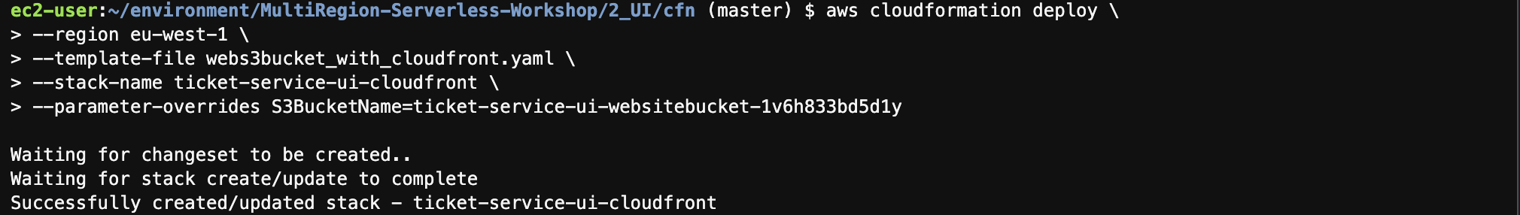

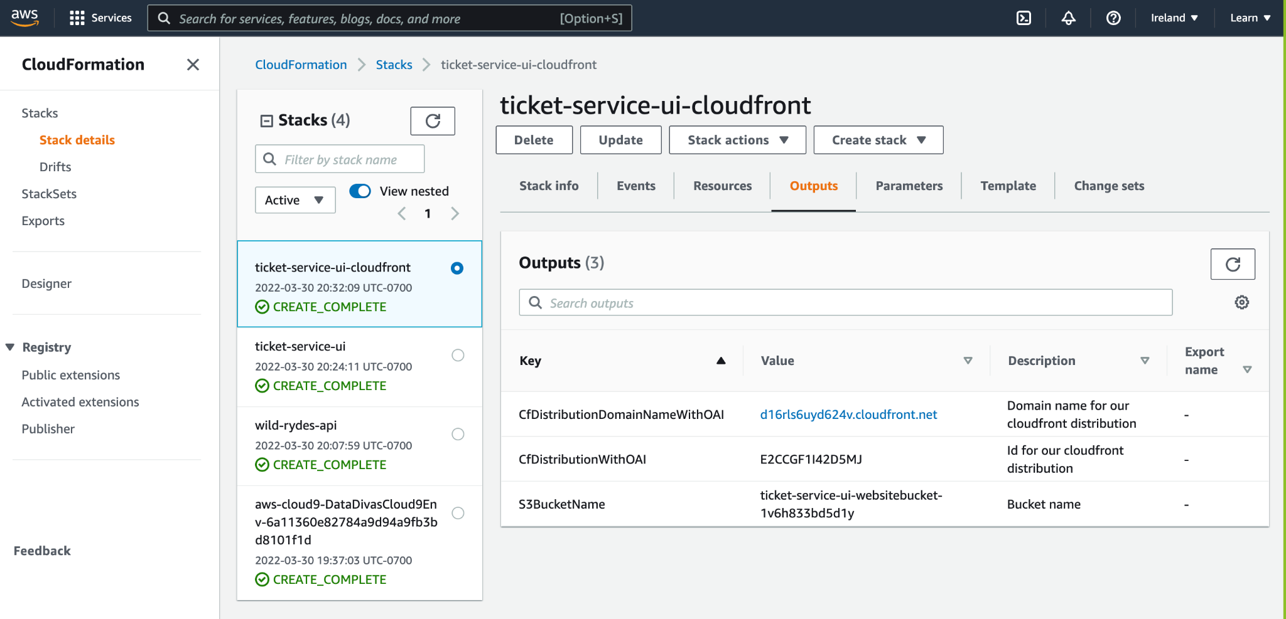

**CfDistributionDomainNameWithOAI Value:**

[d16rls6uyd624v.cloudfront.net](http://d16rls6uyd624v.cloudfront.net/)

## 2. Configure Federated Identities with Cognito

Creating a New App

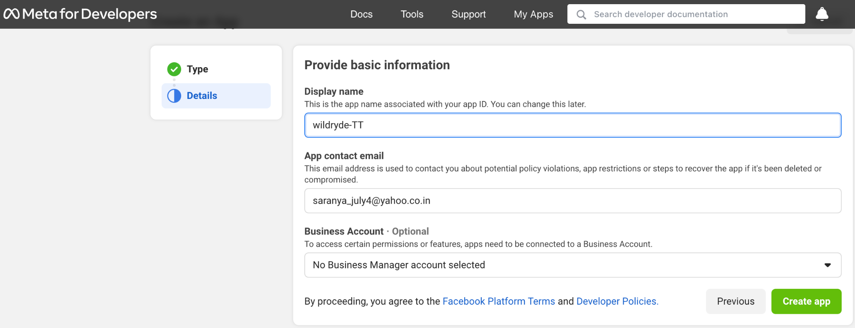

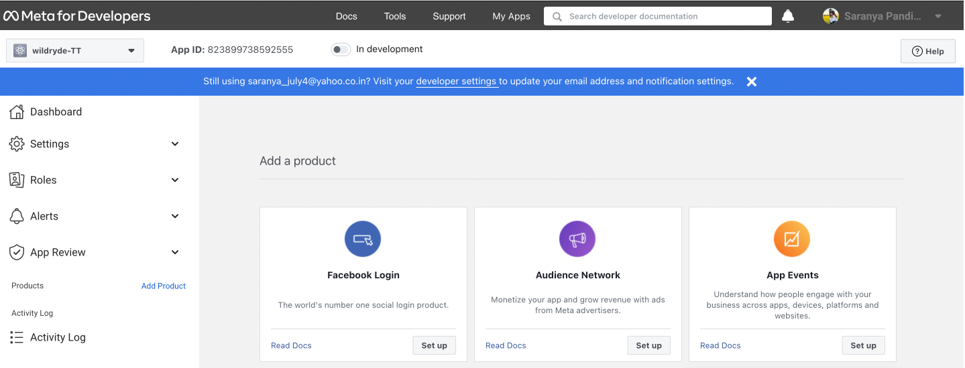

**Adding Platform**

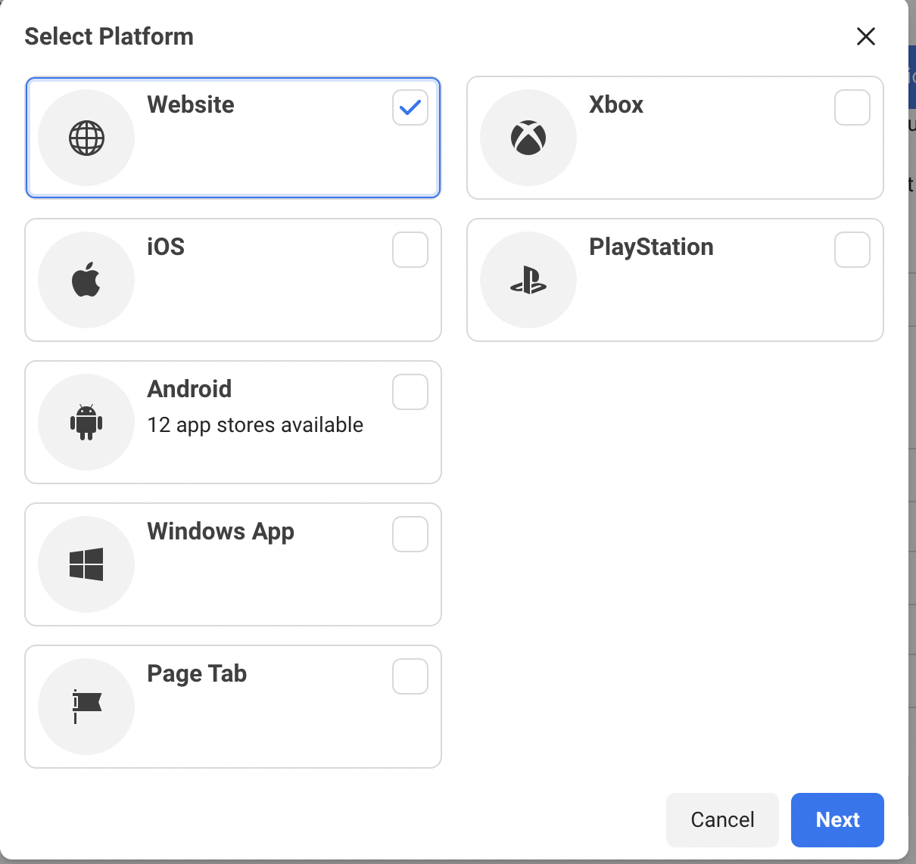

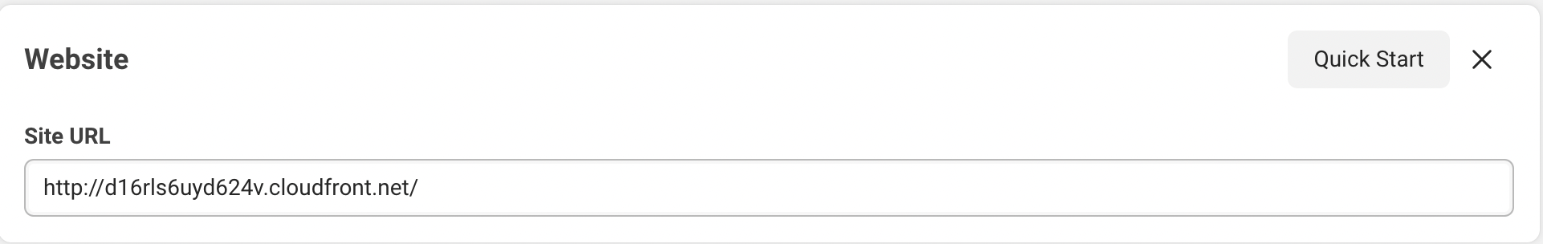

**App ID:** [**823899738592555**](https://developers.facebook.com/apps/823899738592555/settings/basic/)

**Cognito Identity Pool with Facebook as identity provider**

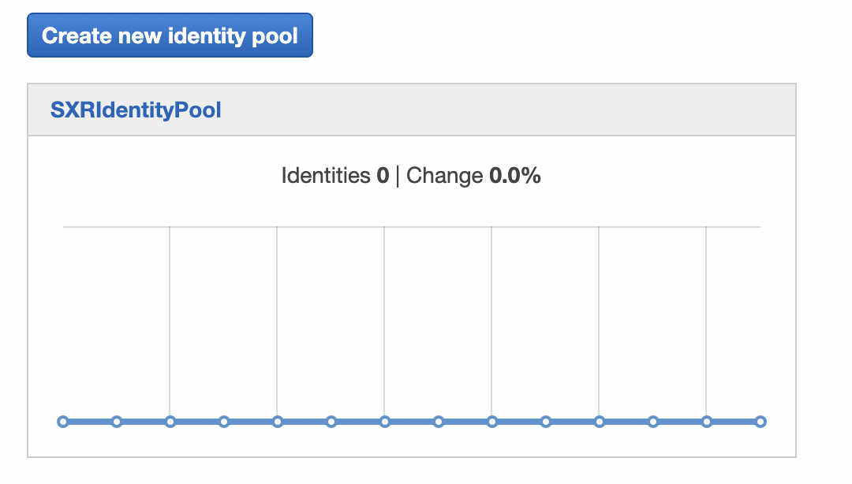

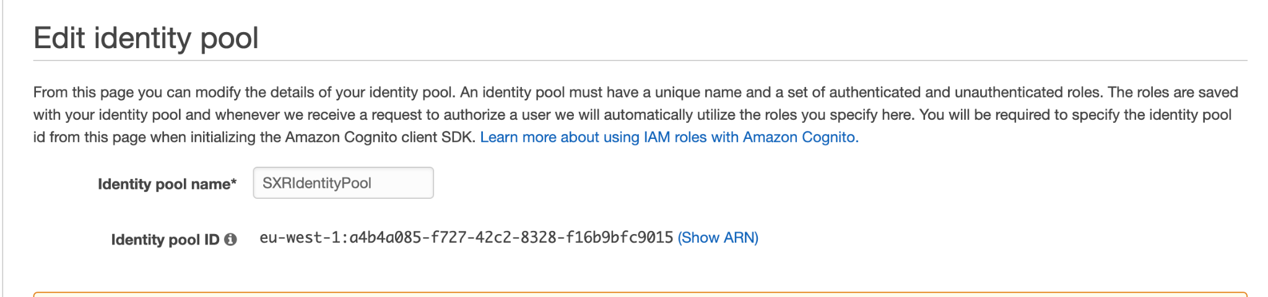

**Identity pool ID: eu-west-1:a4b4a085-f727-42c2-8328-f16b9bfc9015**

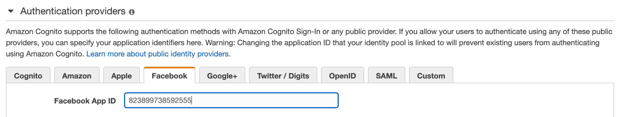

## 3. Configure and build the application code

Configuring the attributes in Environment.ts file

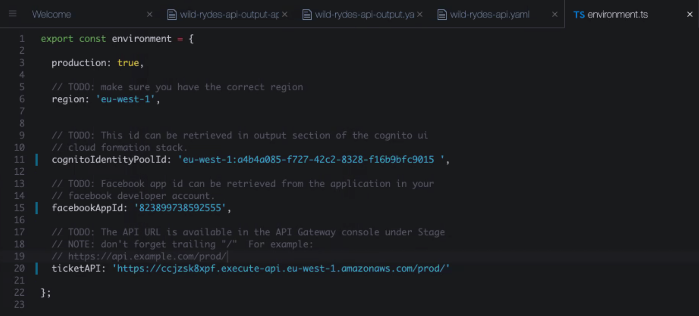

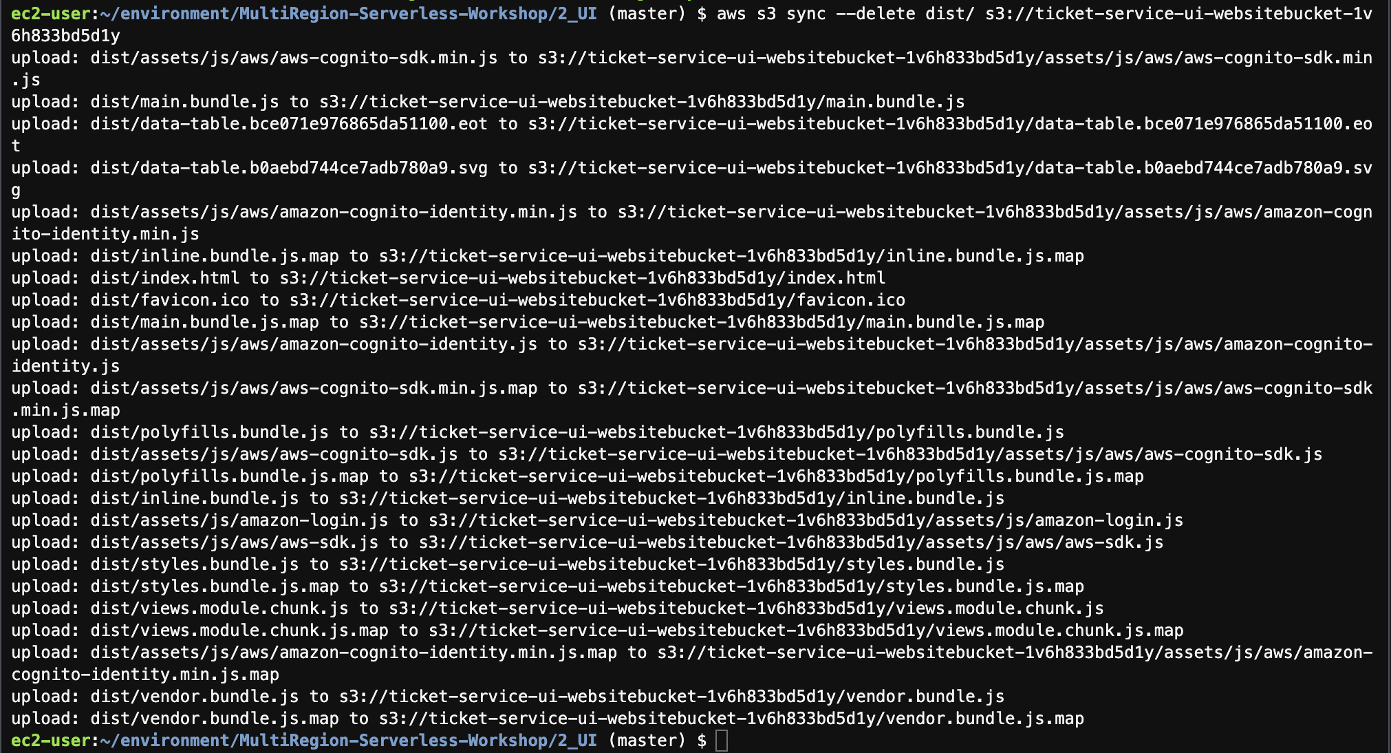

**Build your AngularJS Project**

Running npm install to install project dependencies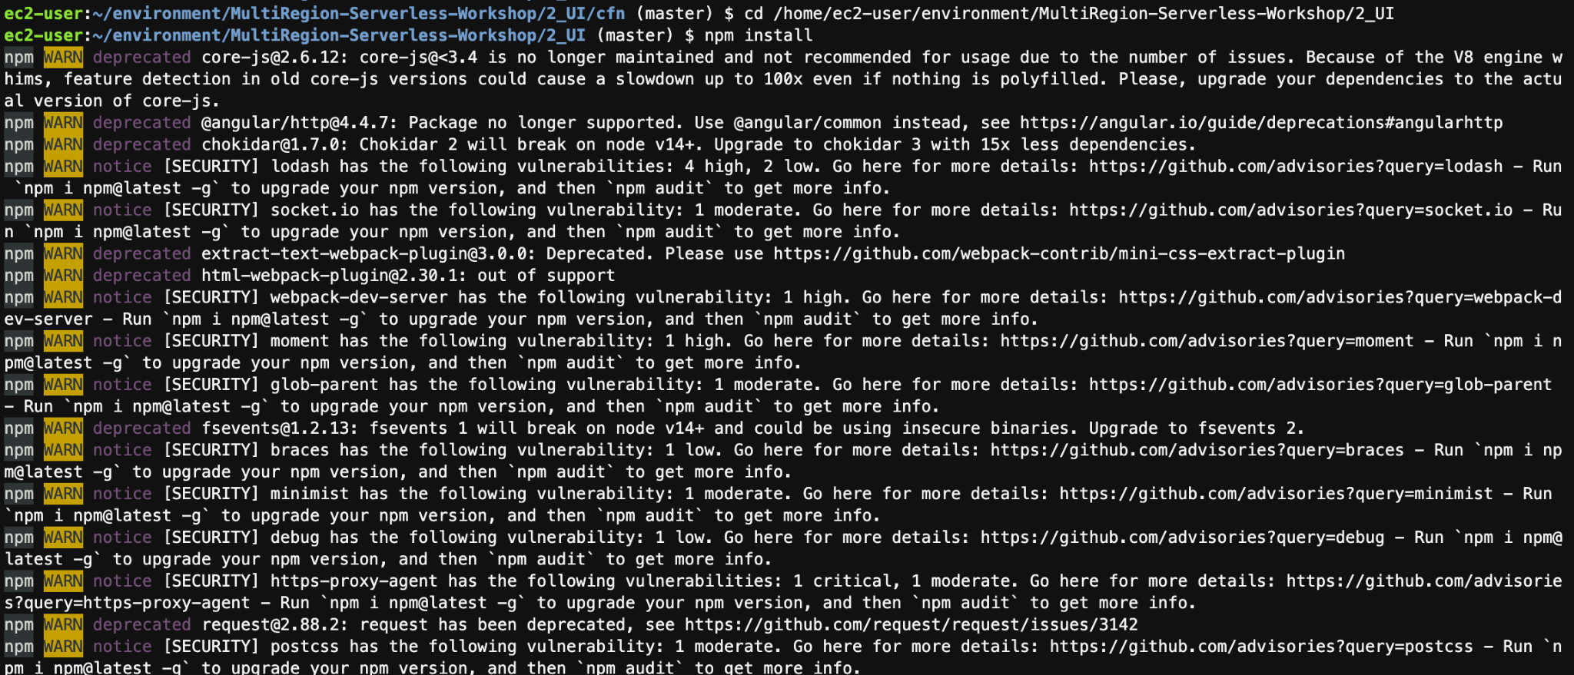

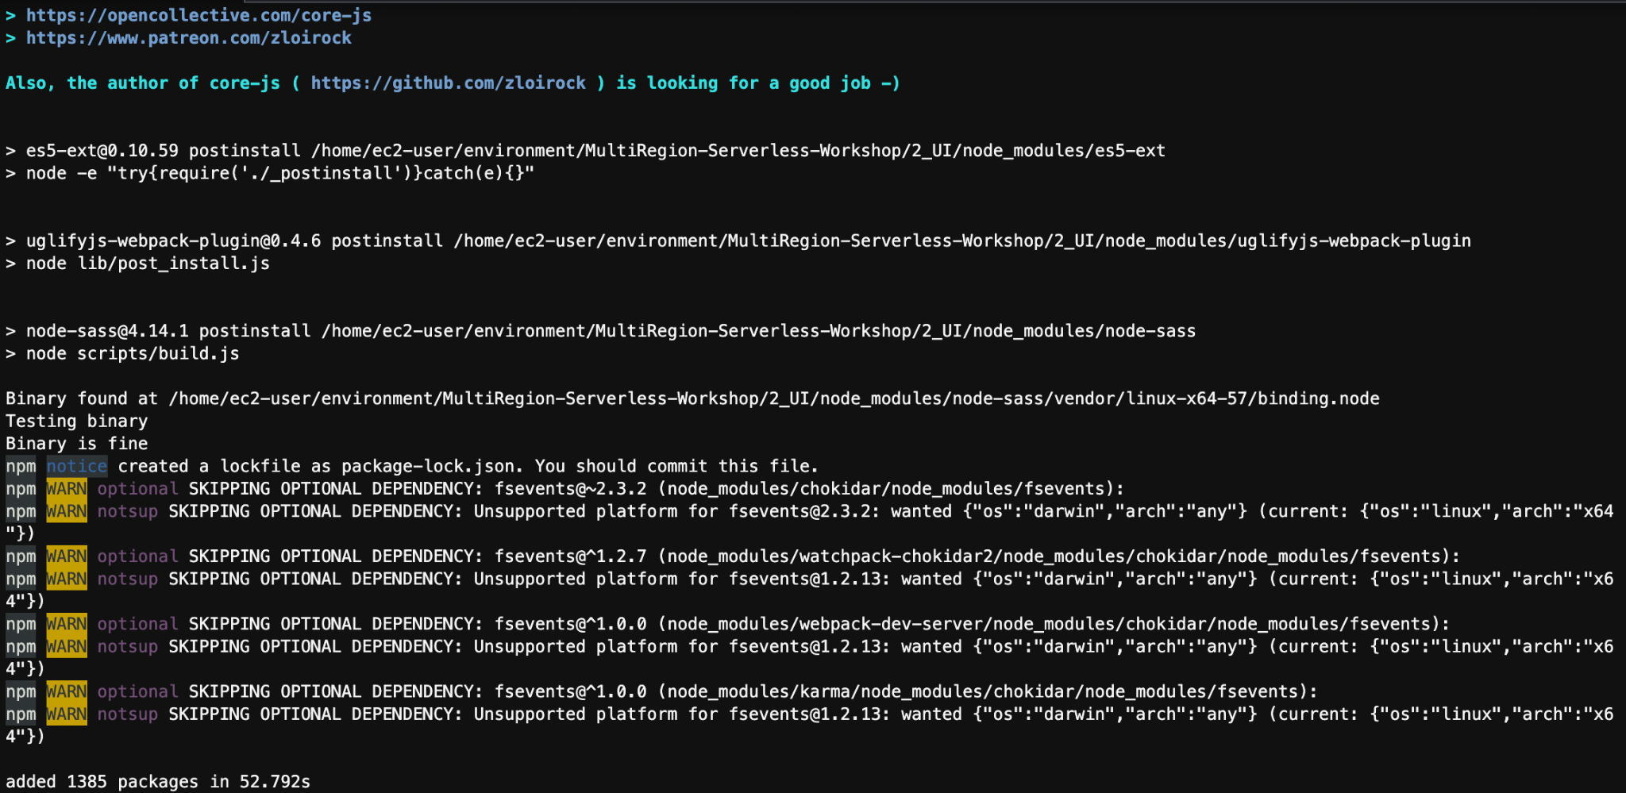

**Building the app**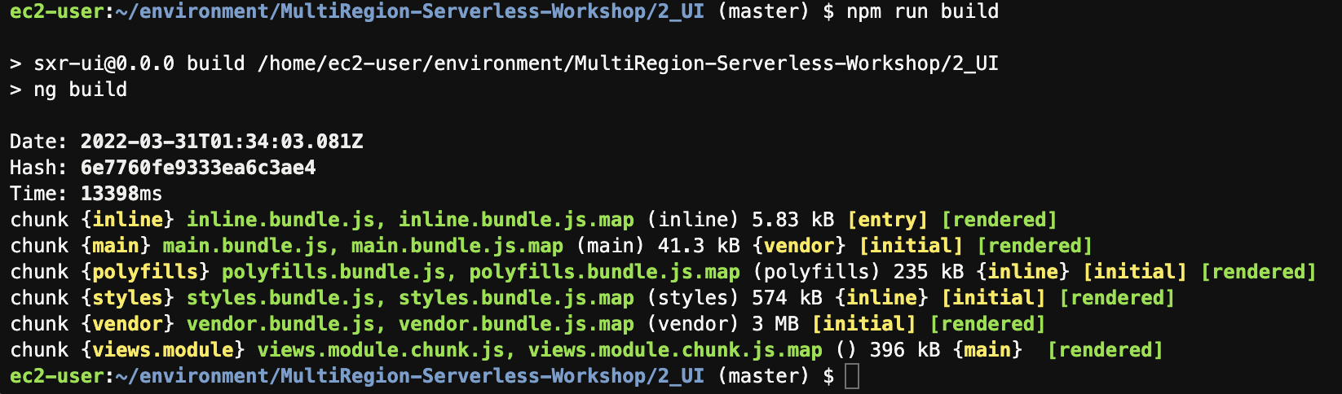

**Creating a dist/ folder containing the compiled app**

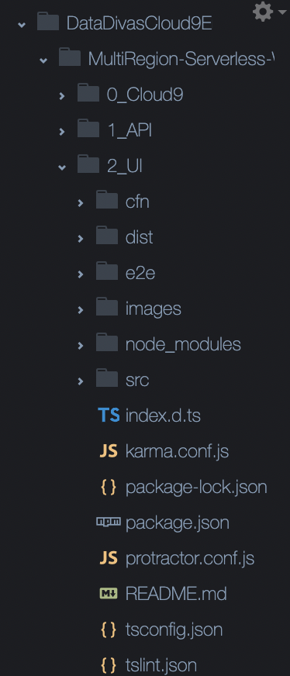

## 4. Upload the application

aws s3 sync --delete dist/ s3://ticket-service-ui-websitebucket-1v6h833bd5d1y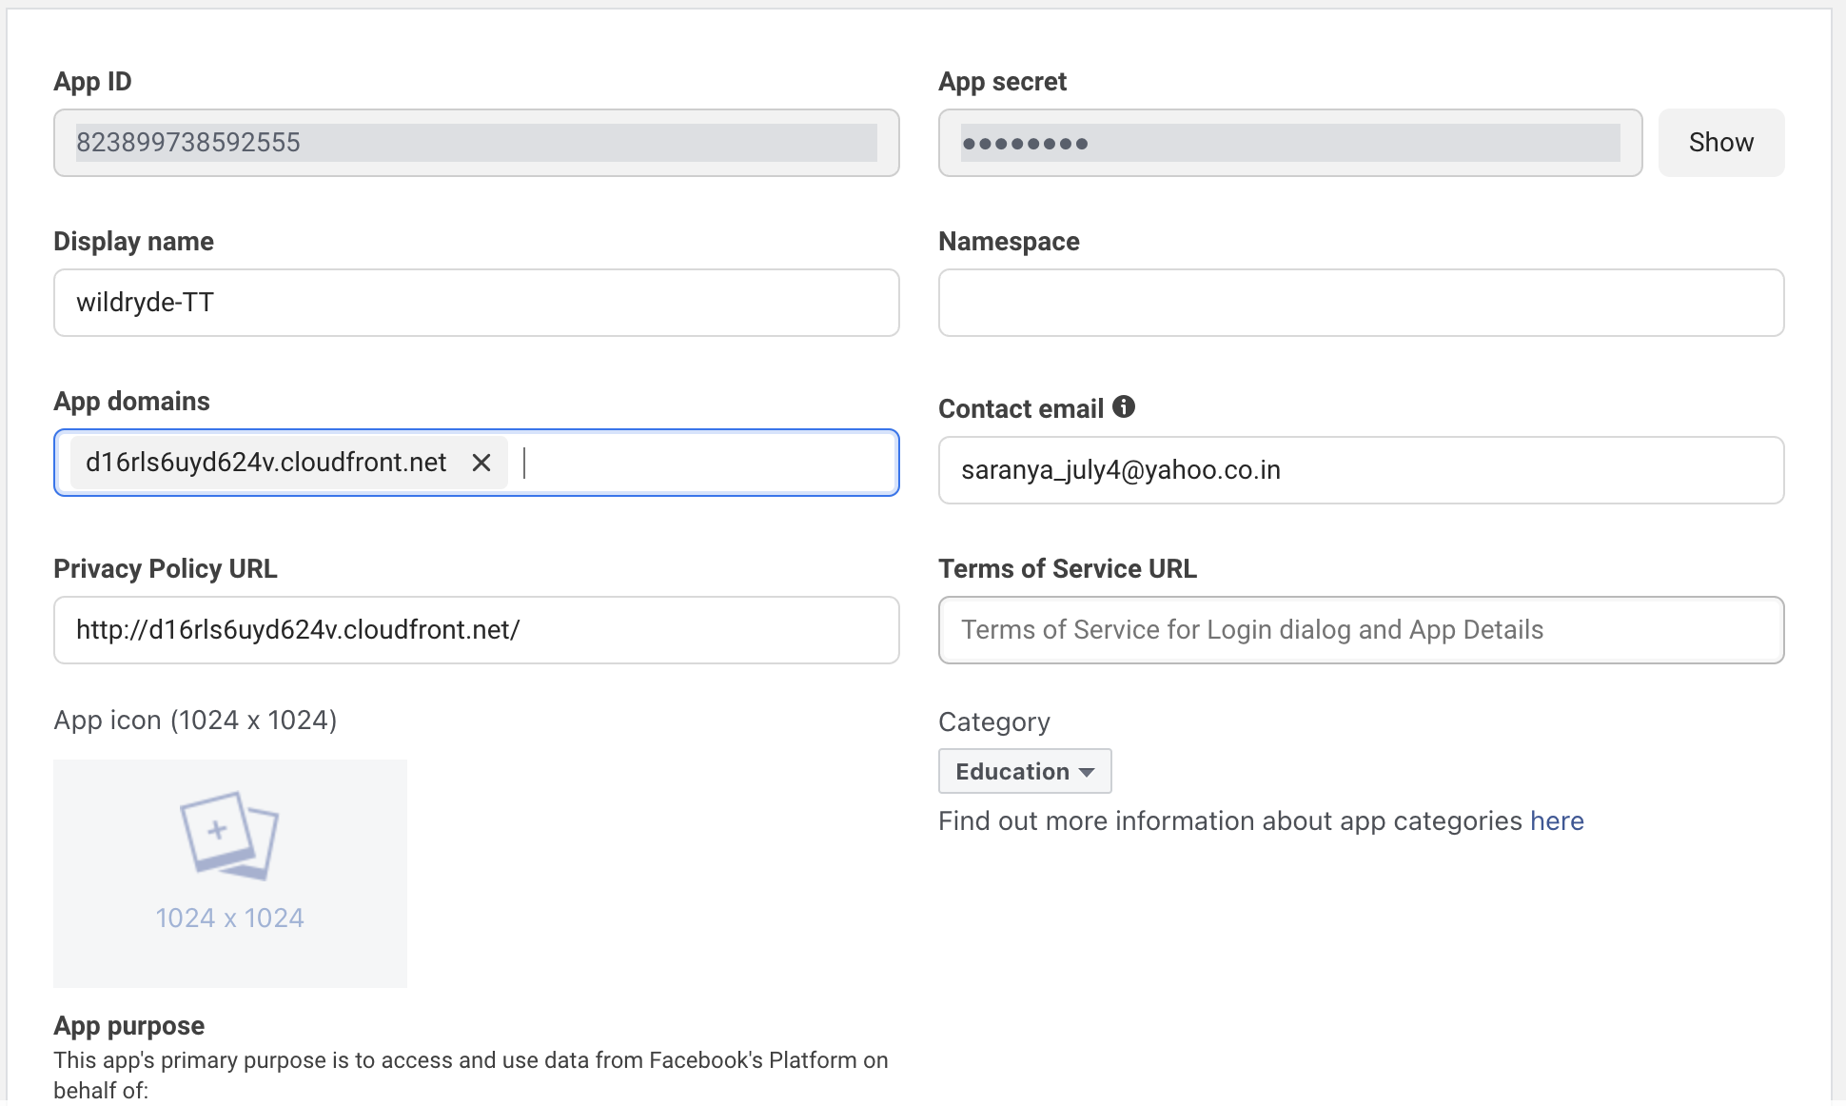

**Went Live:**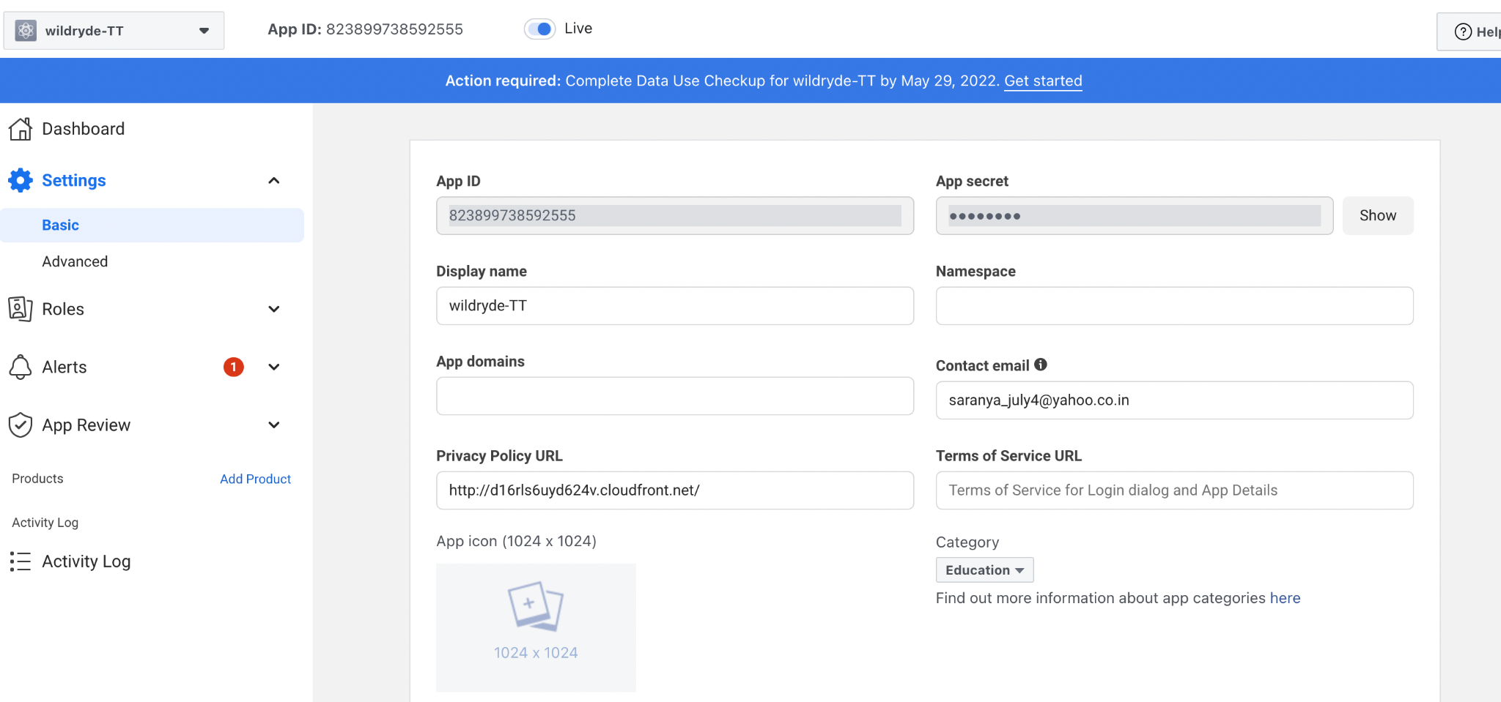

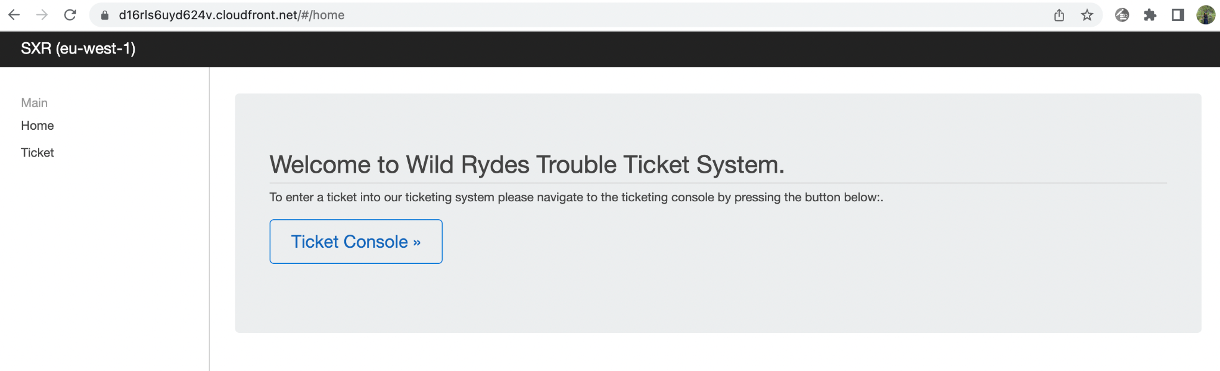

# 4. Route53

## 1. Configure Route53 Domain

**Purchasing a domain Name**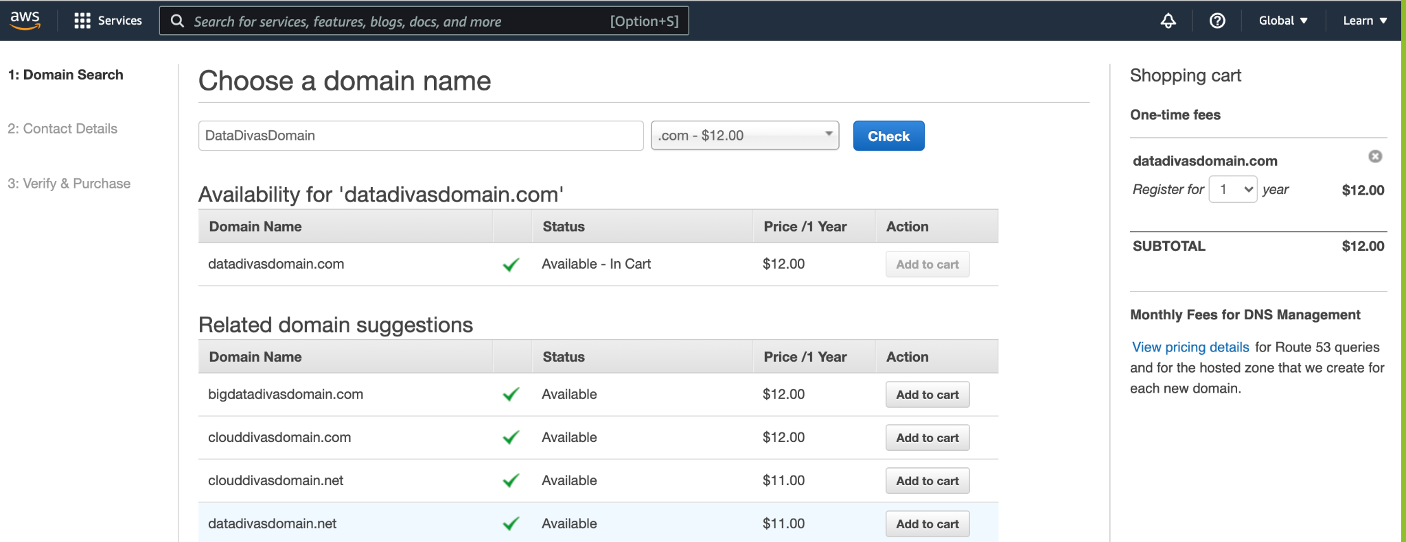

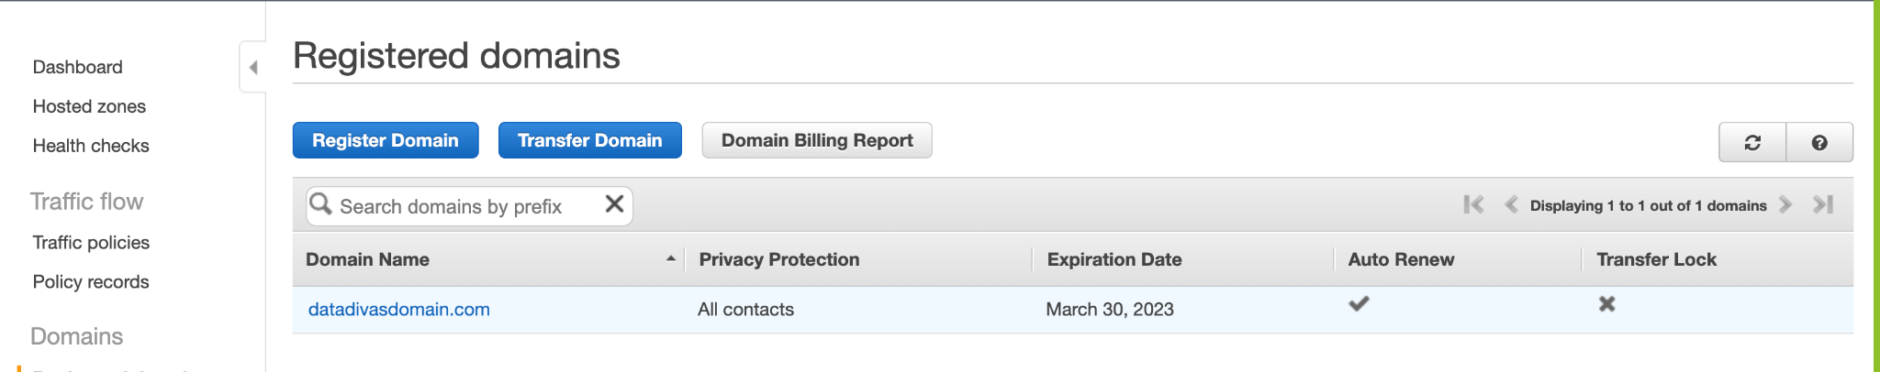

## 2. Configure ACM and Custom Domains in API Gateway

2.1 Configure a certificate in Certificate Manager in each region

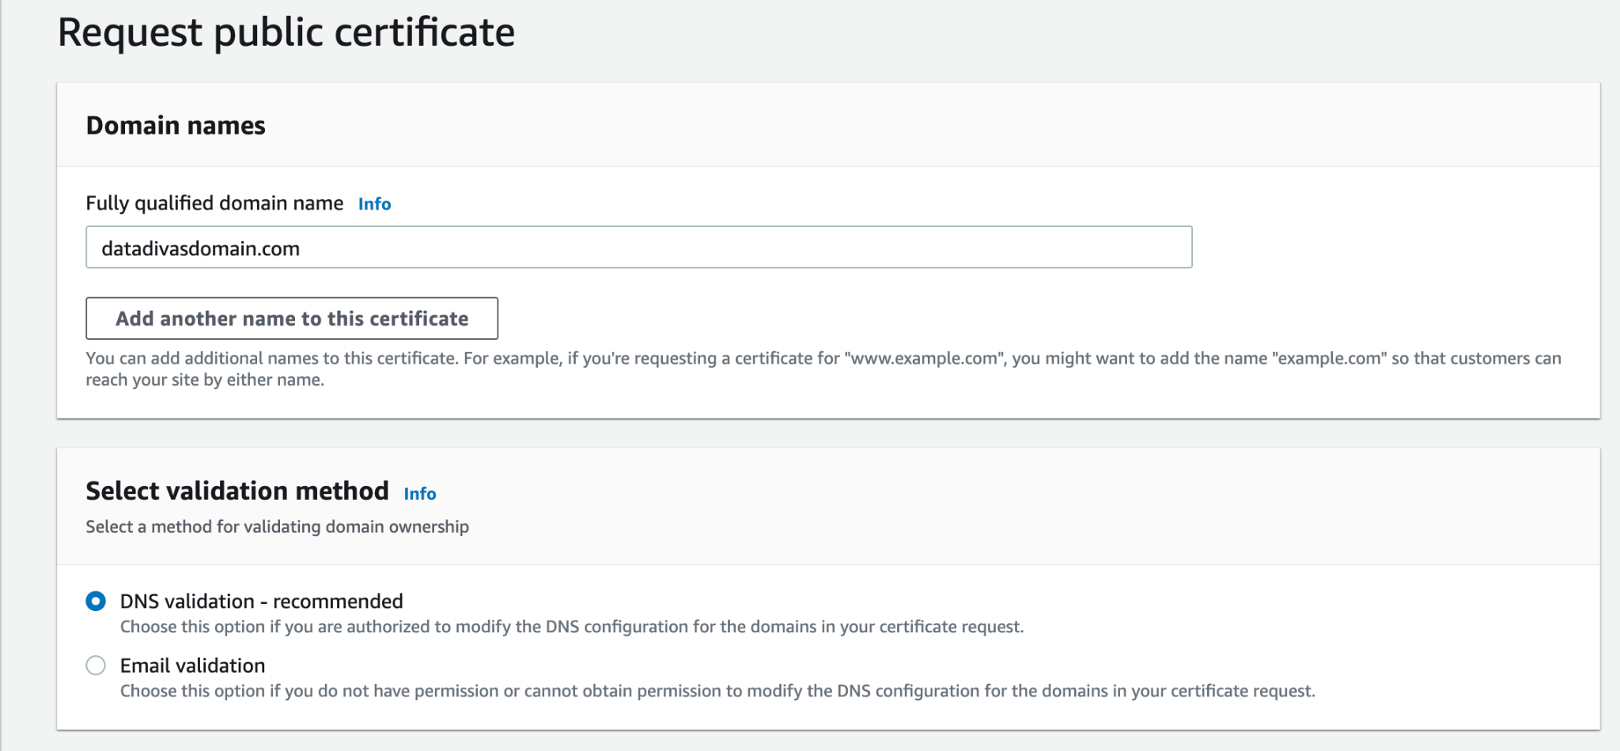

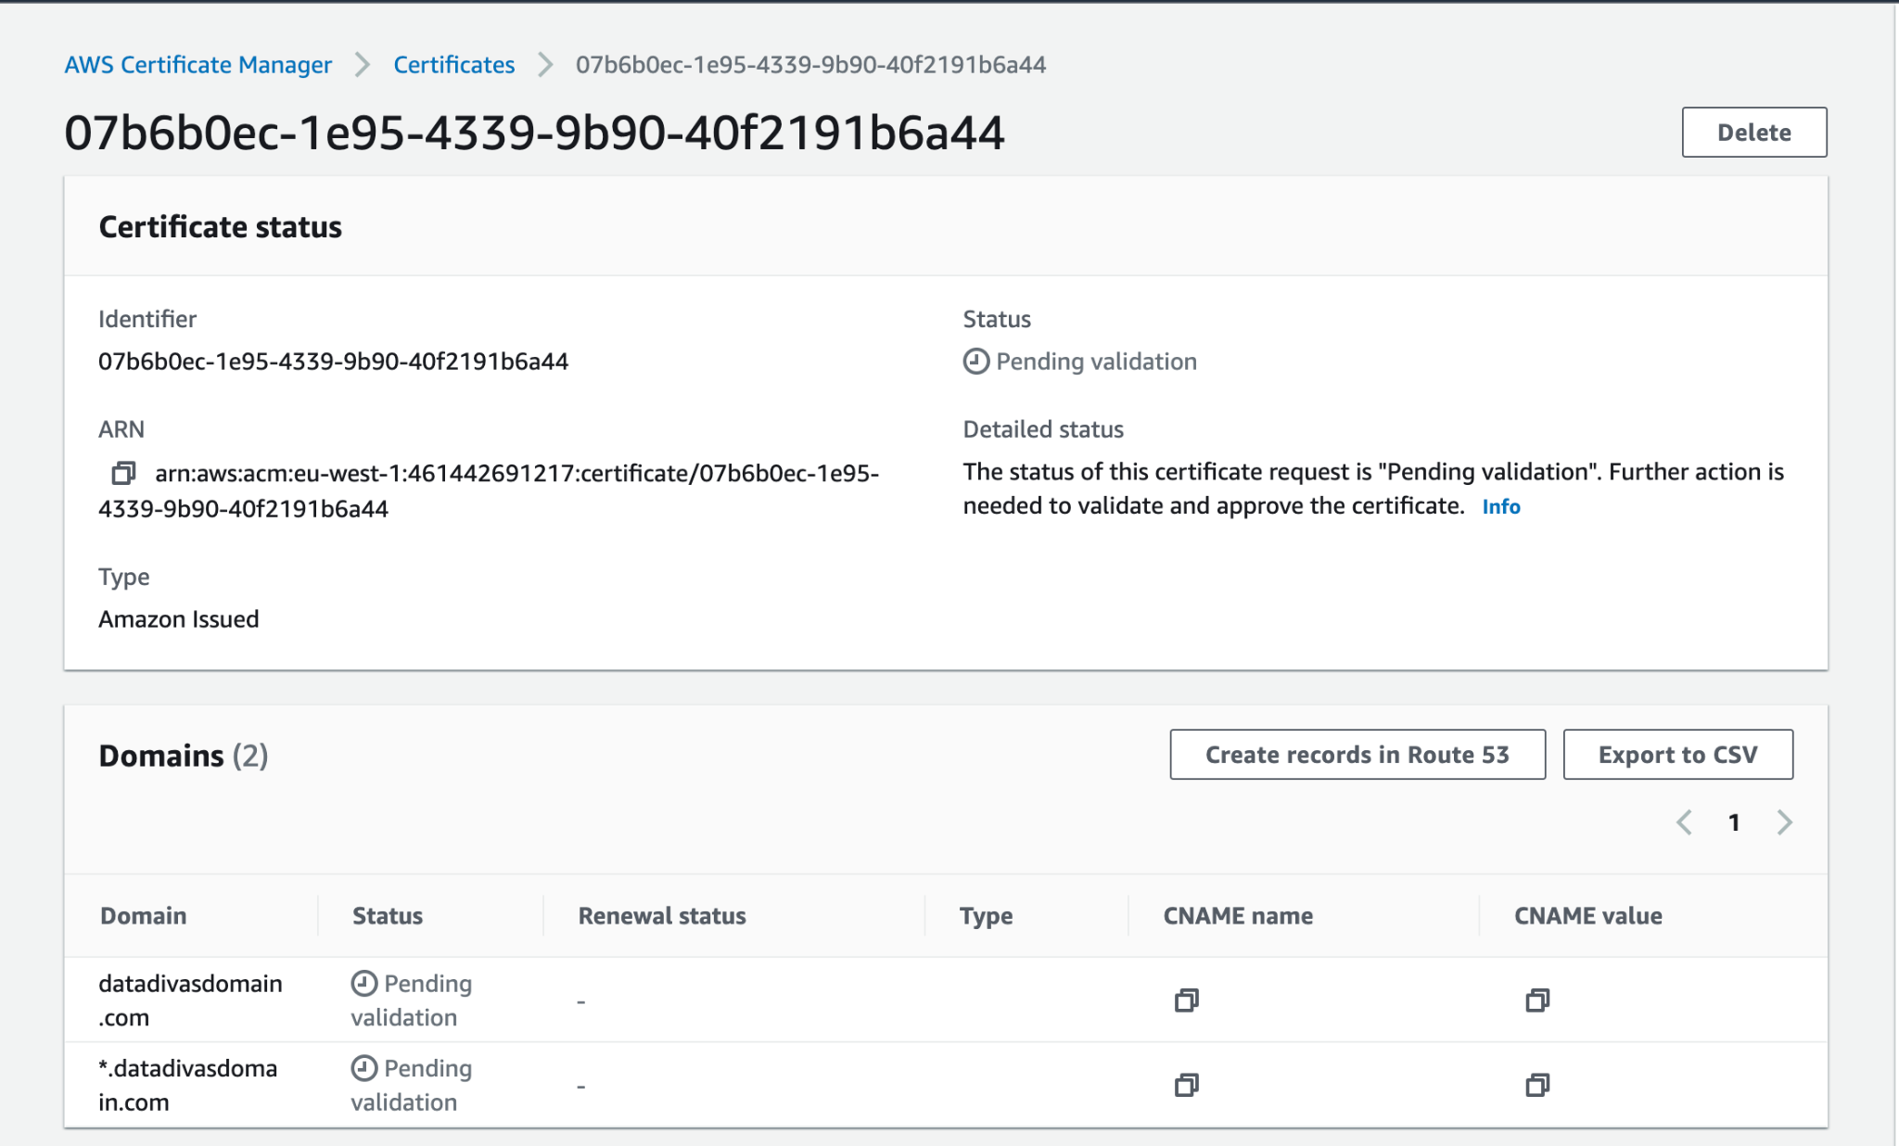

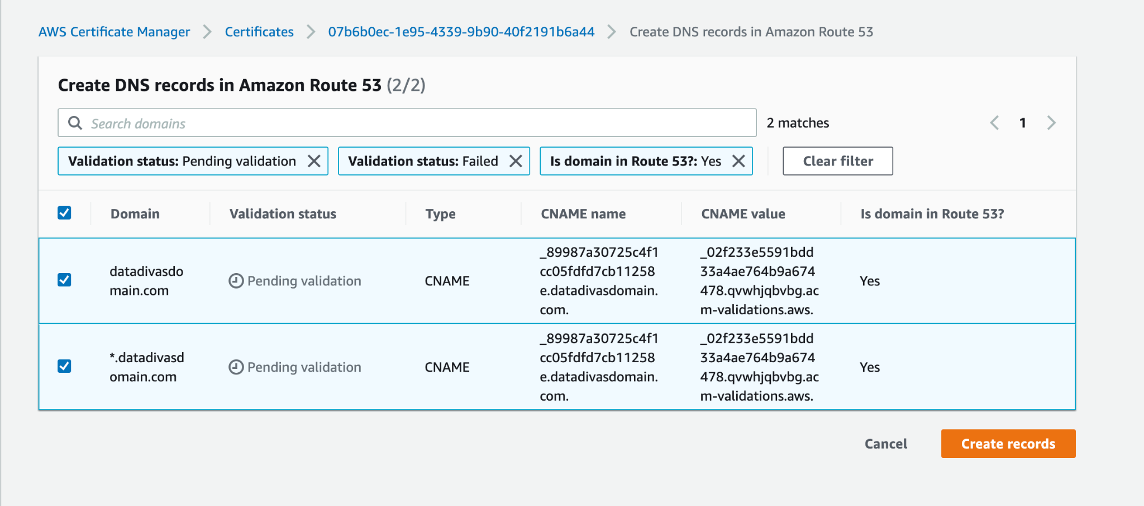



**Ireland**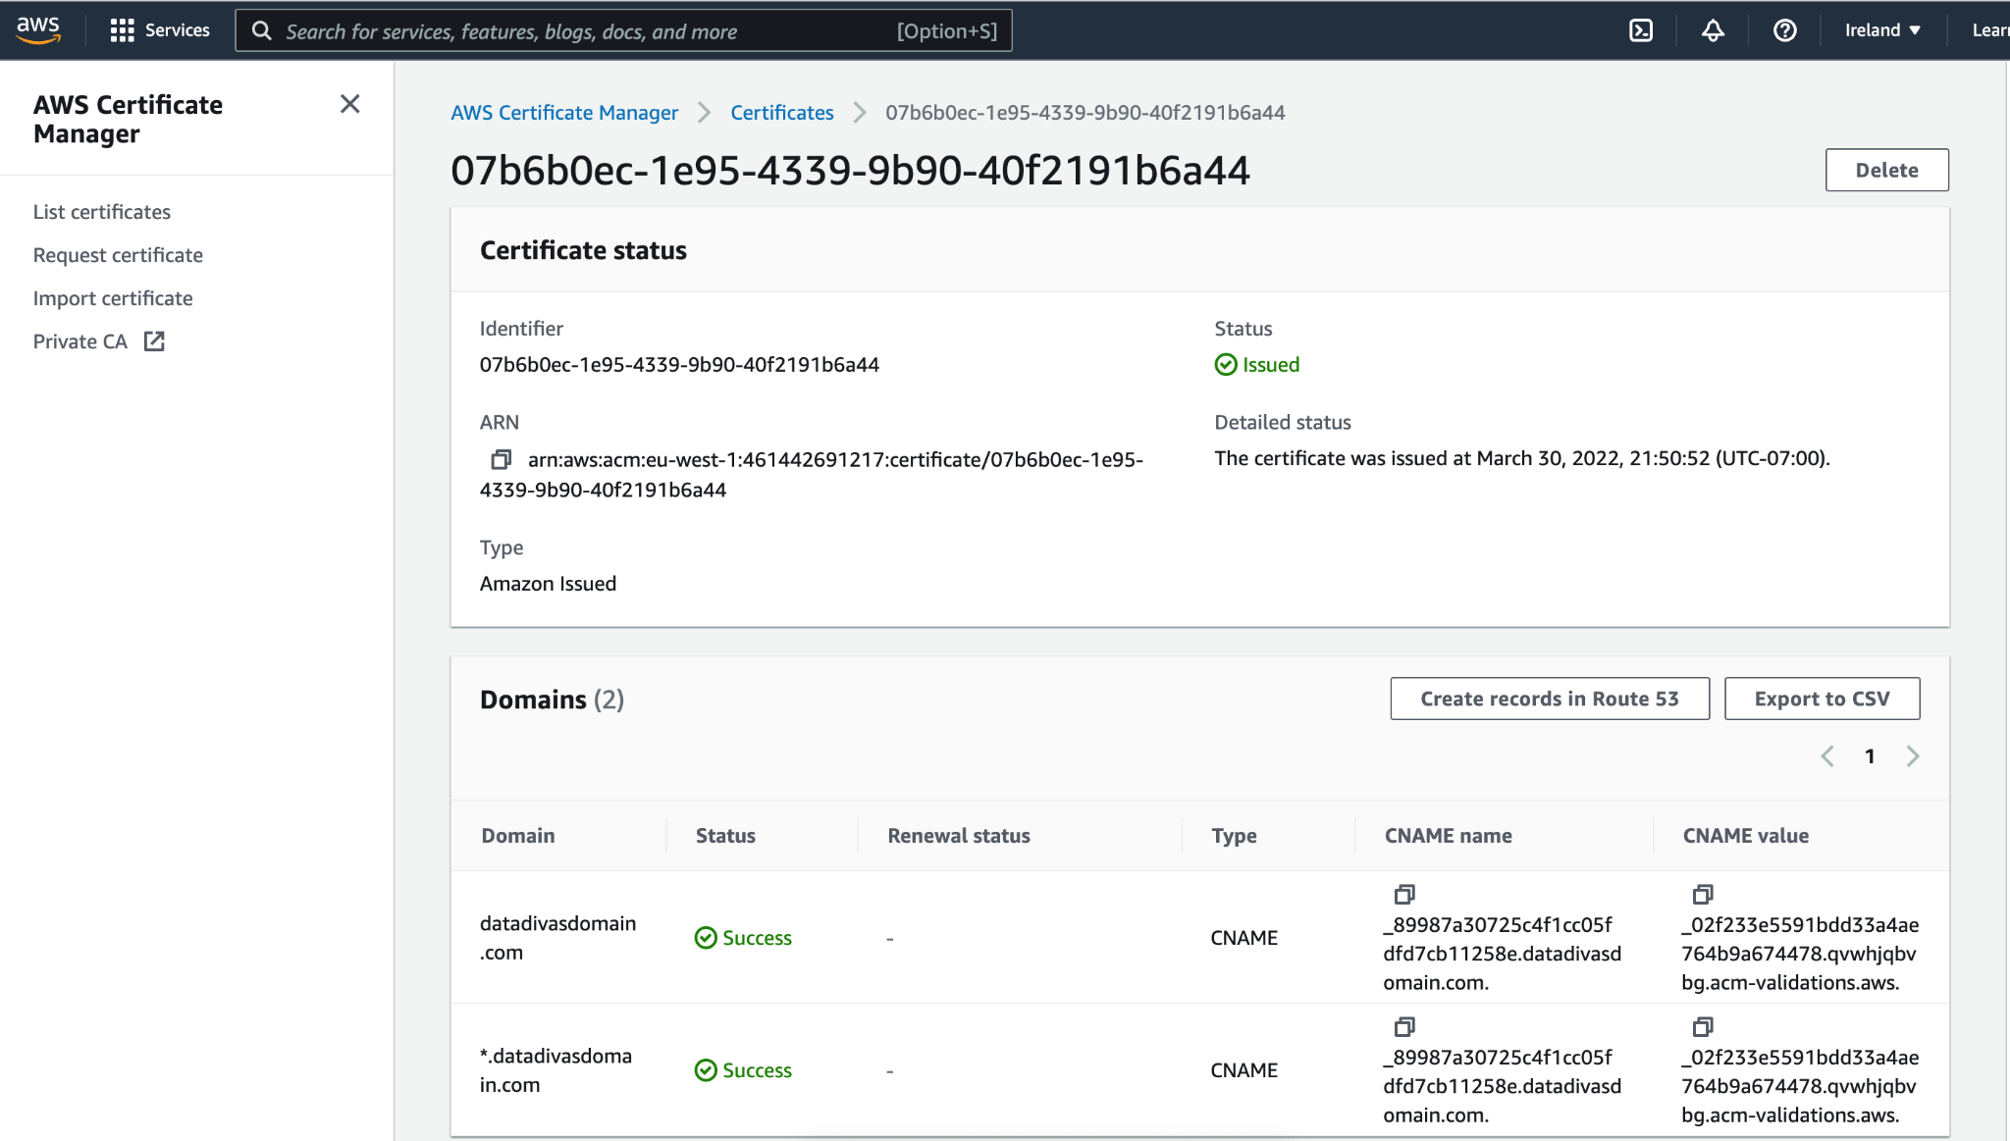

**Singapore**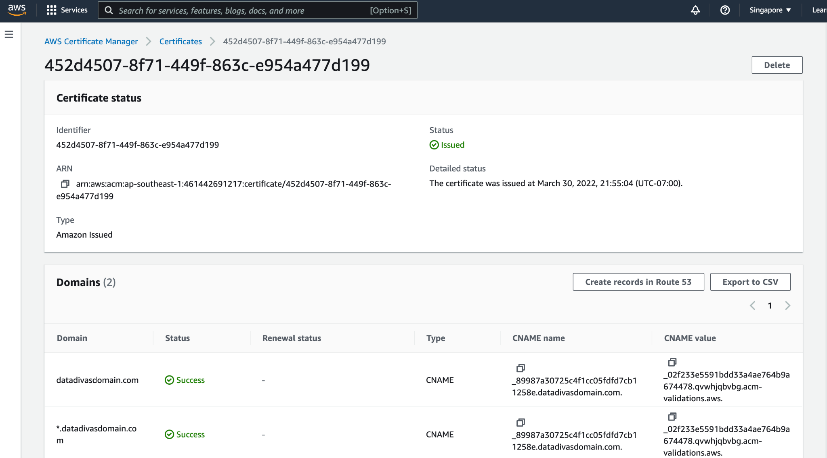

2.2 Configure custom domains on each API in each region

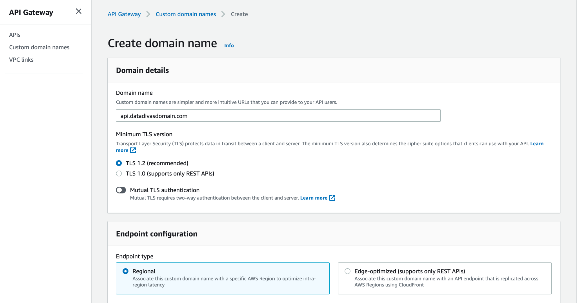

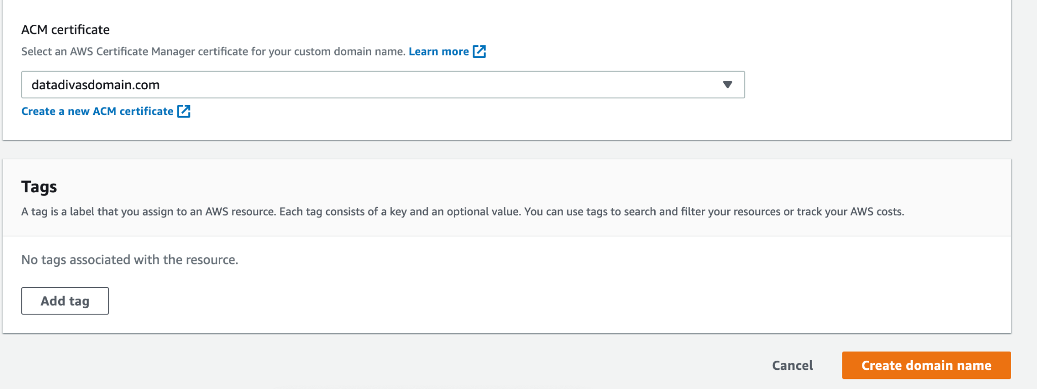

**Configuring API Mapping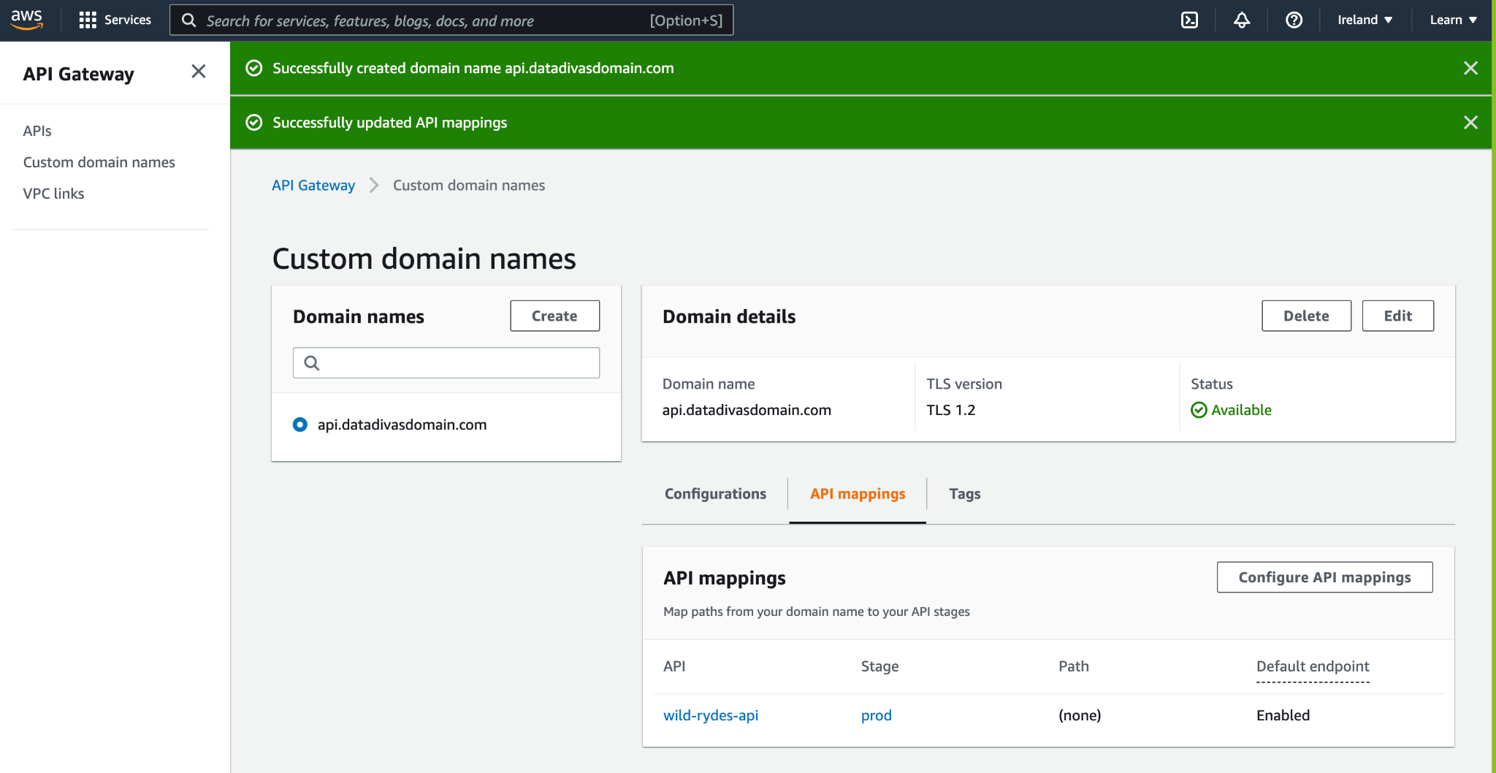Ireland**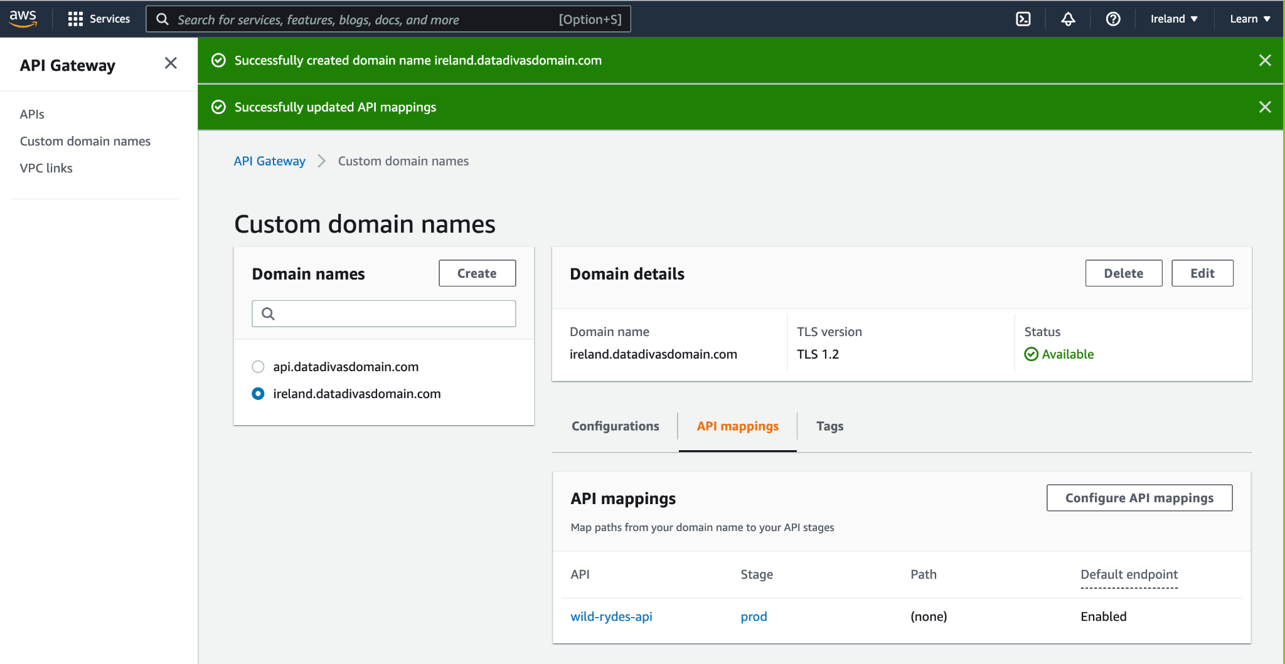

**Singapore**

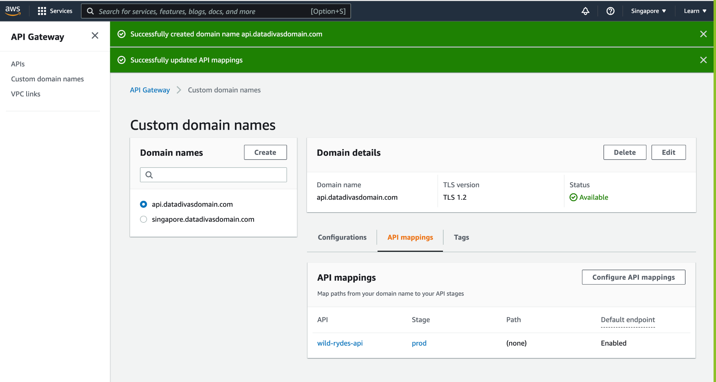

## 

## 3. Configure Route53 DNS records

3.1 Configure DNS records

**Ireland**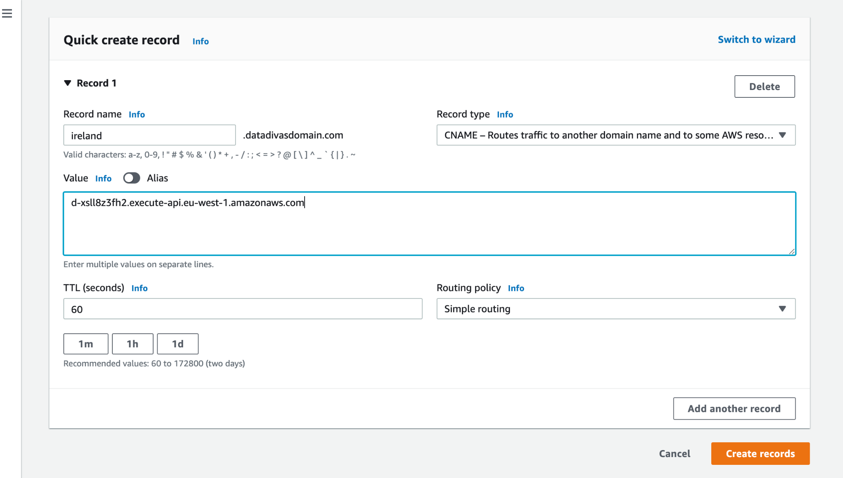

**Singapore**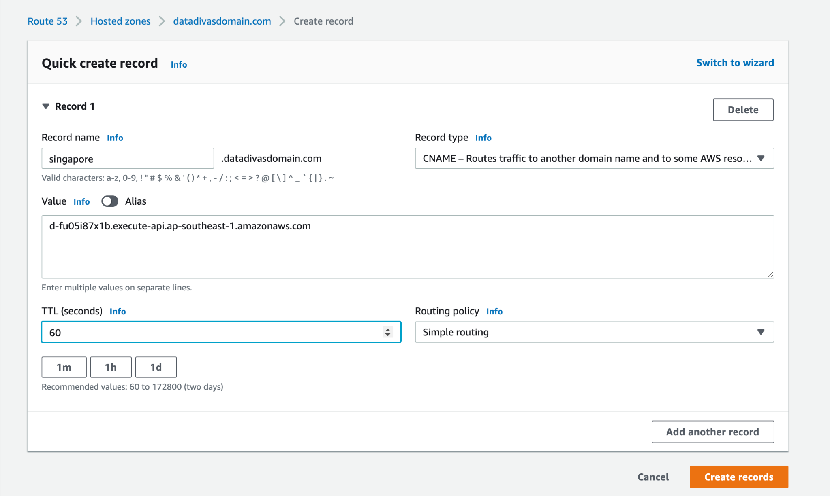

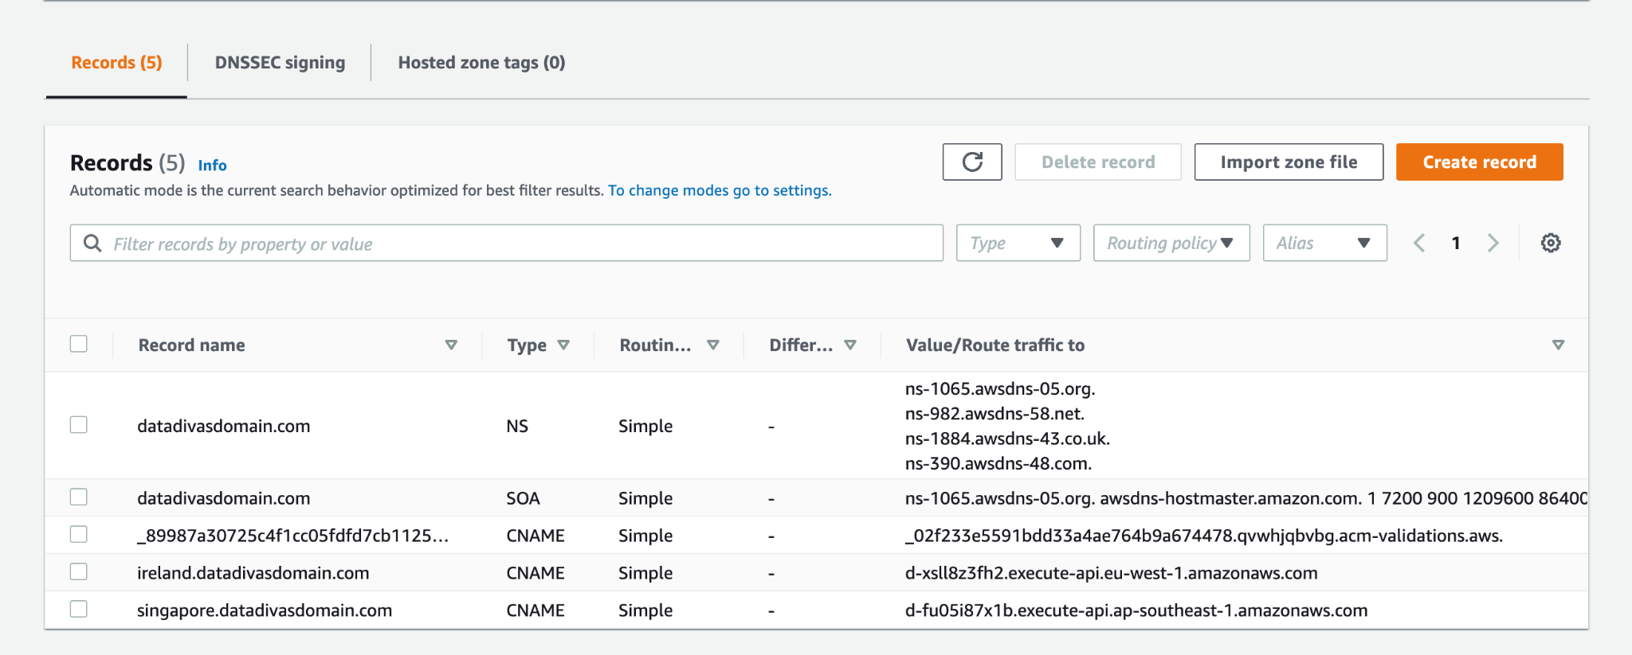

**Checking endpoint on API :**[**https://ireland.datadivasdomain.com/health**](https://ireland.example.com/health)

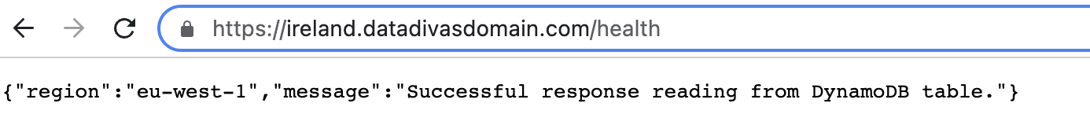

**Checking endpoint on API :**[**https://singapore.datadivasdomain.com/health**](https://ireland.example.com/health)

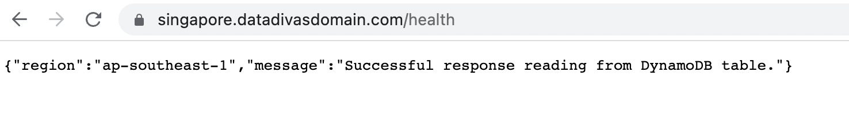

3.2 Configure a health check for both regions

**Ireland**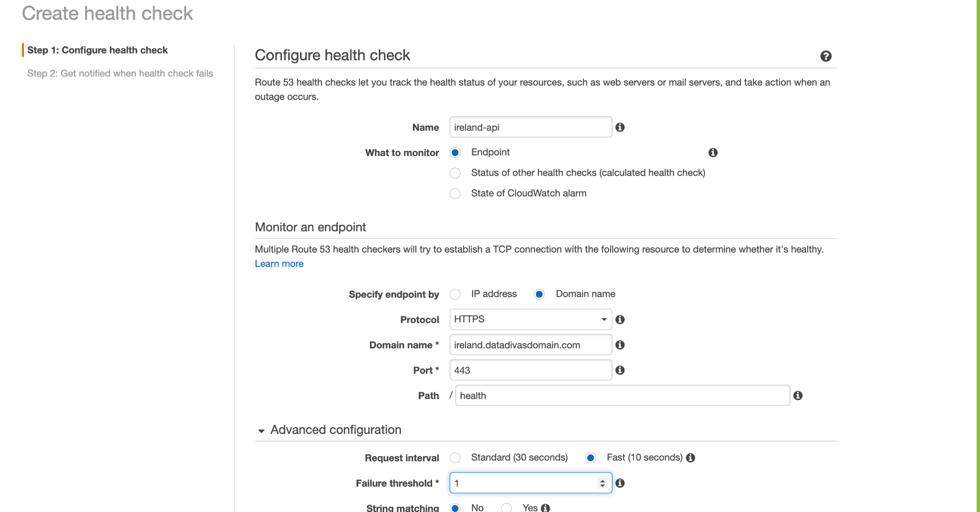

**Singapore**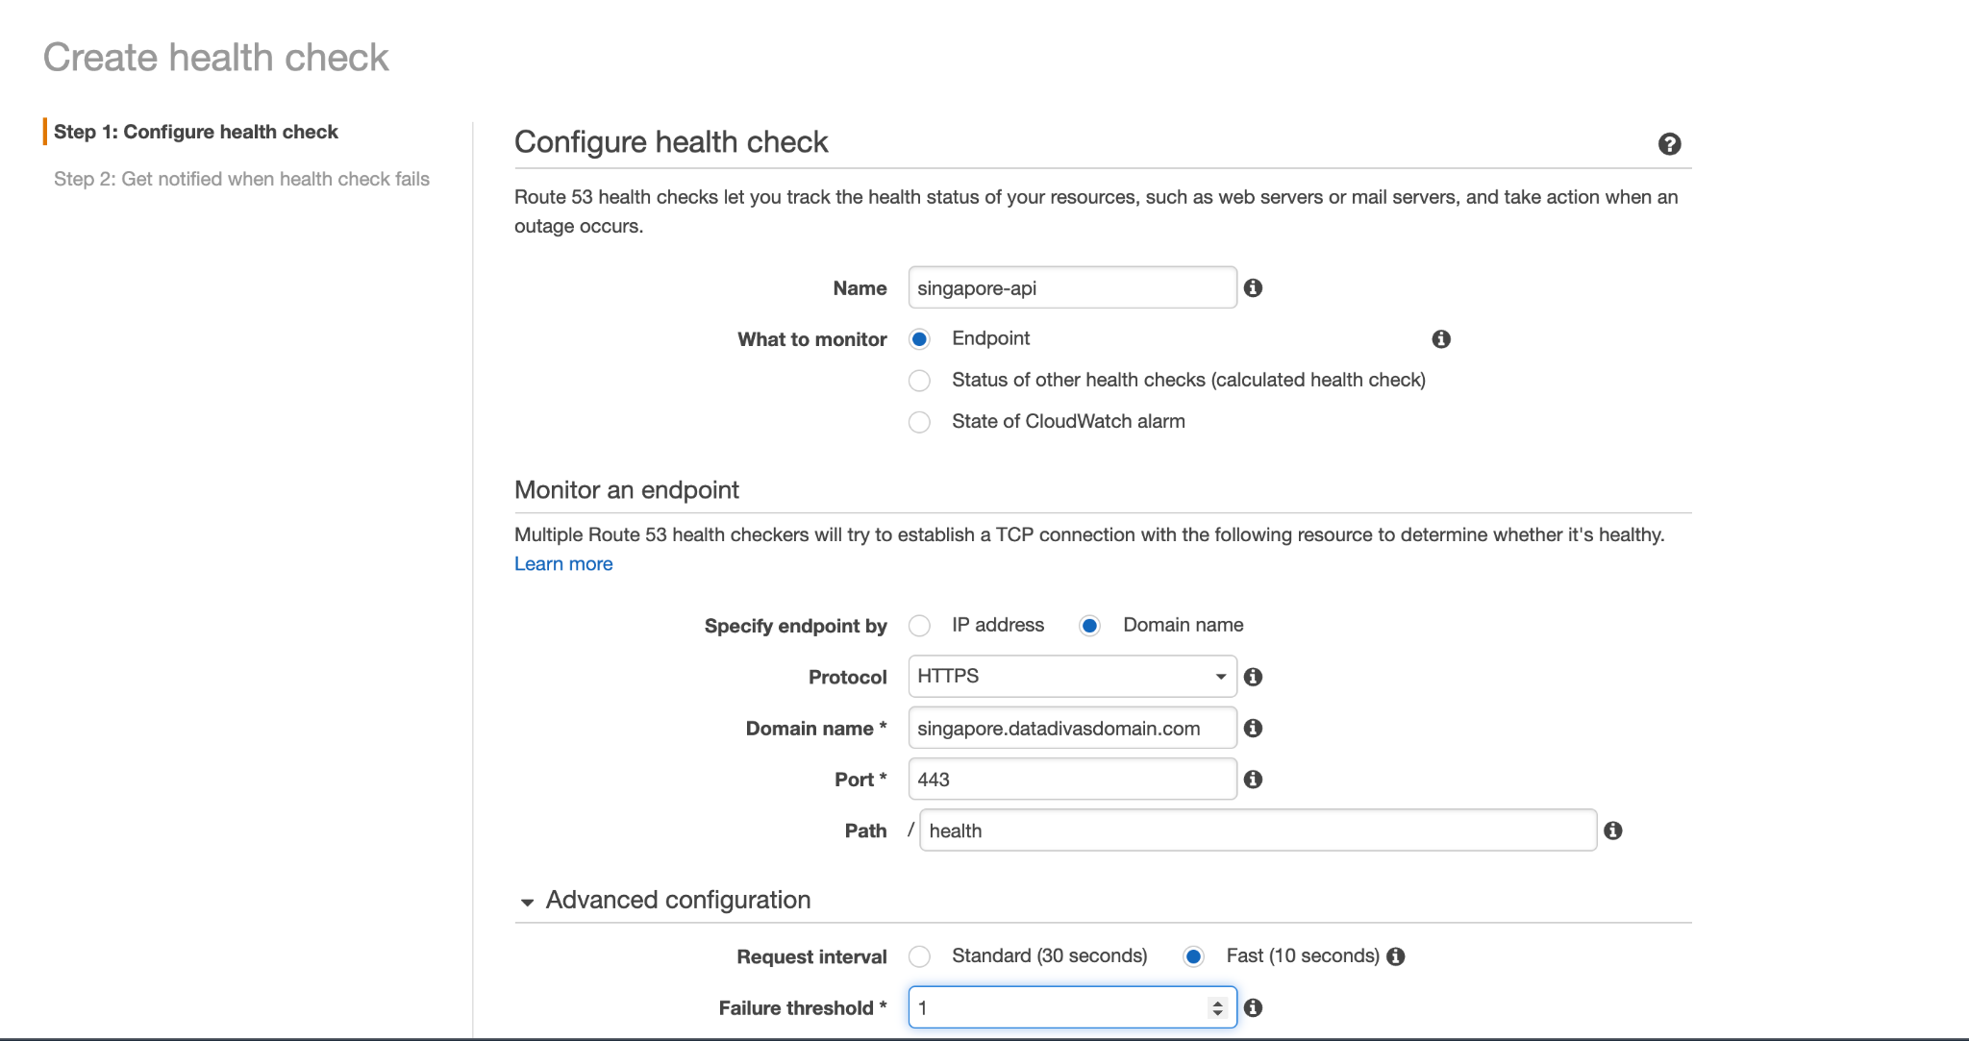

**Health Check**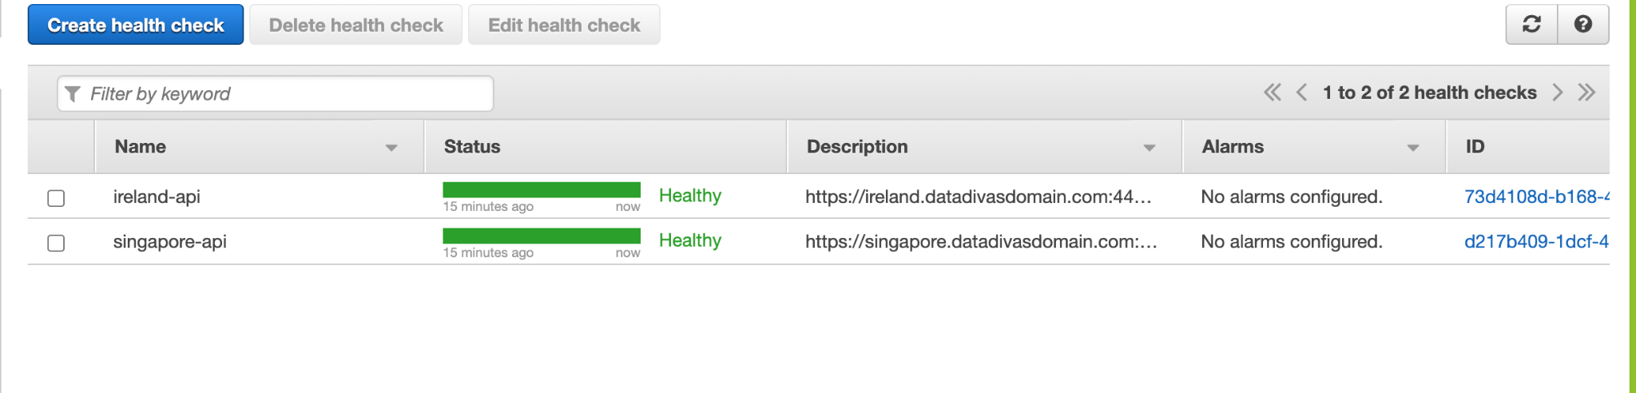

3.3 Configure DNS Routing Policy

**Ireland**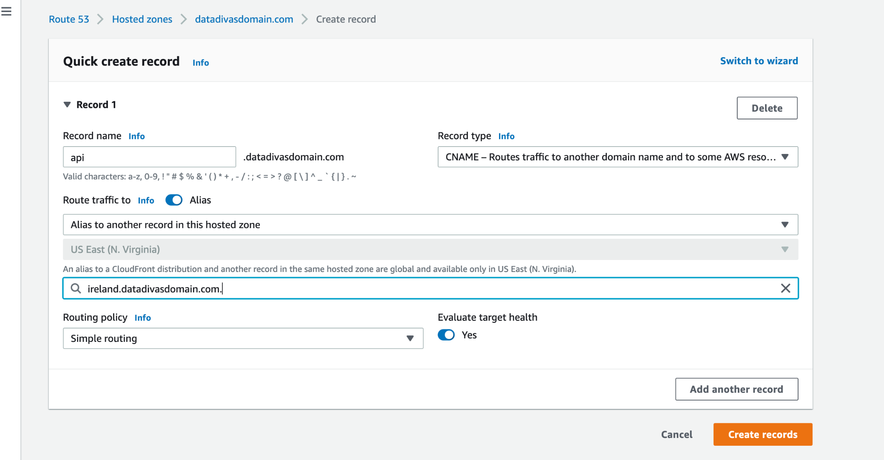

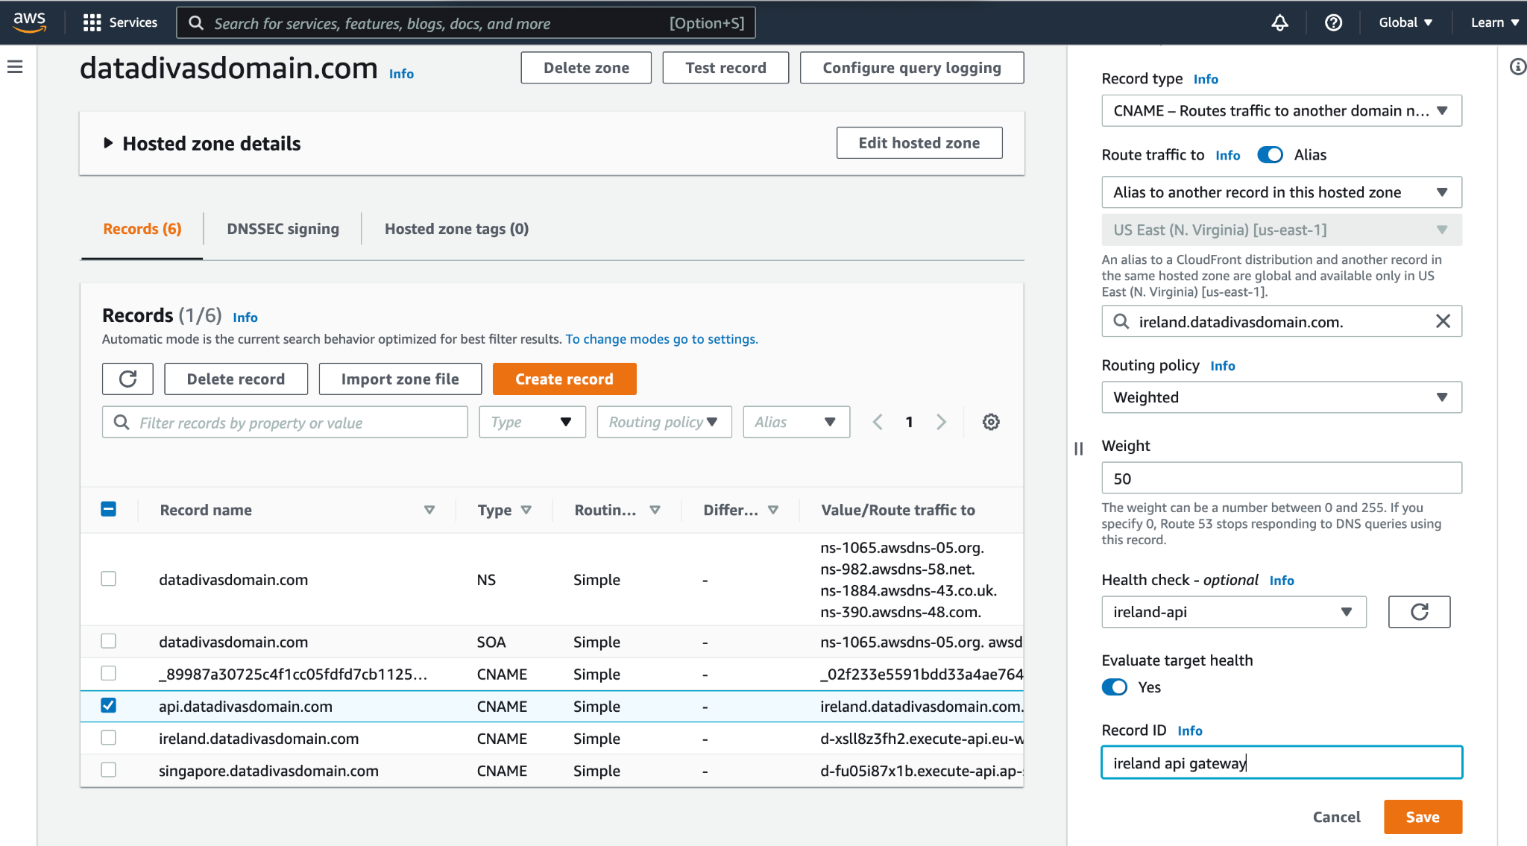

**Singapore**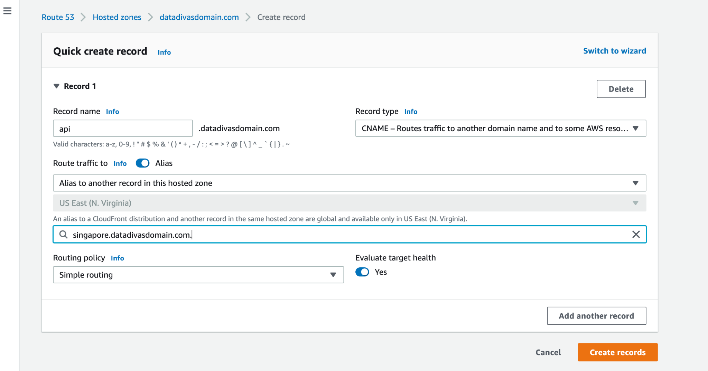

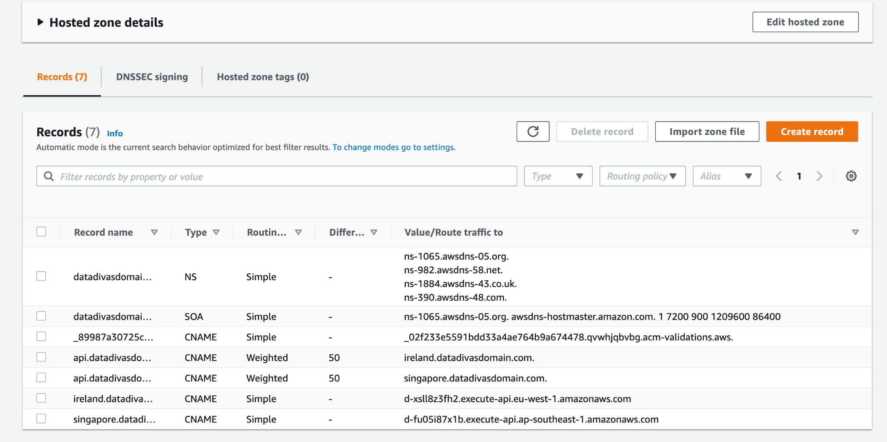

**Checking endpoint on API :**[**https://api.datadivasdomain.com/health**](https://ireland.example.com/health)

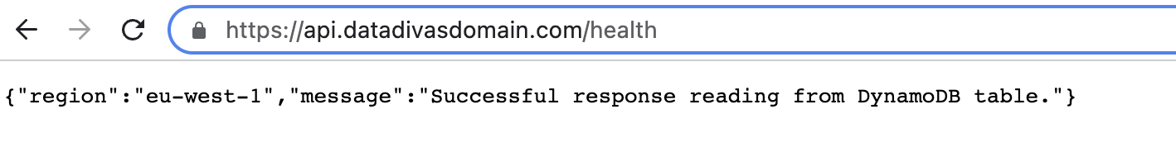

## 4. Update your UI with new API Gateway Endpoint

**Changing the environment file**

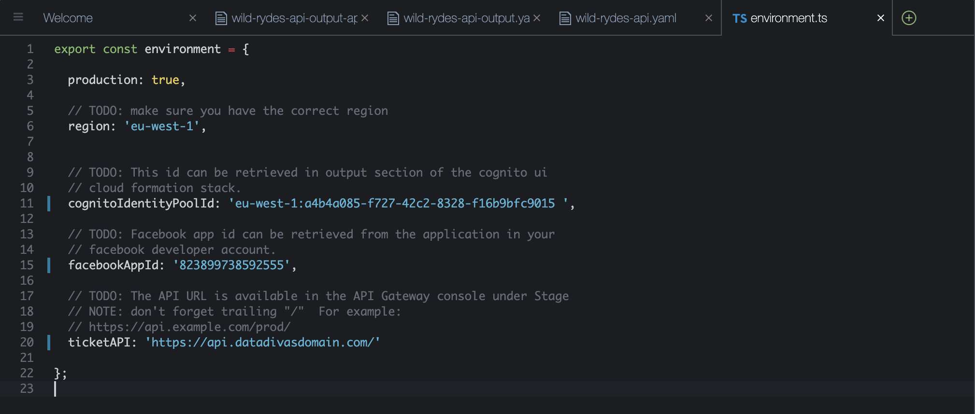

# 5. Test failover

## Testing Multi-region Active-active

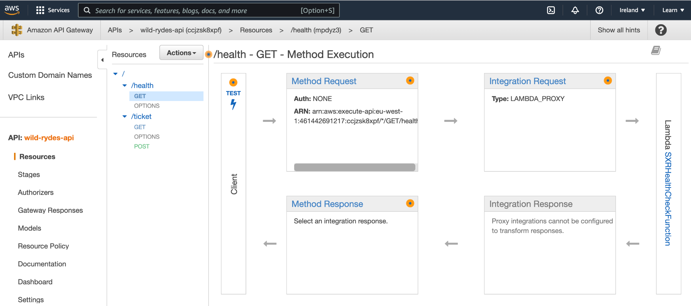

## Breaking the primary region

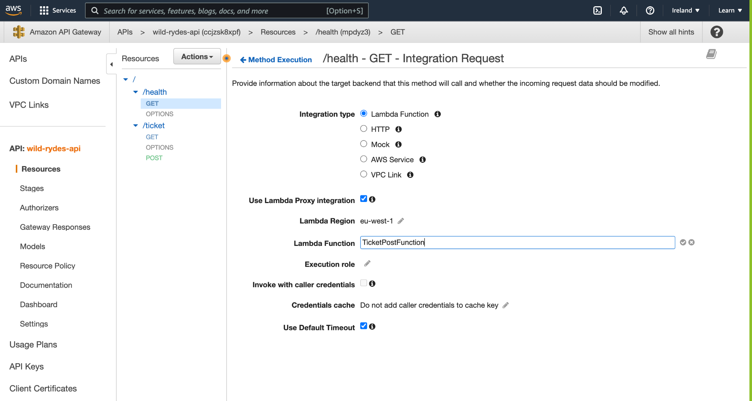

## Deploying the API to prod stage

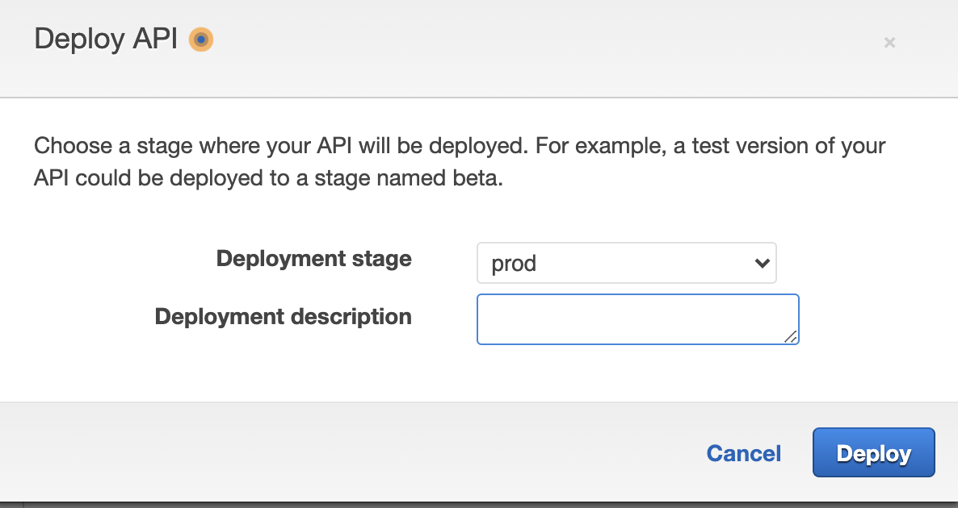

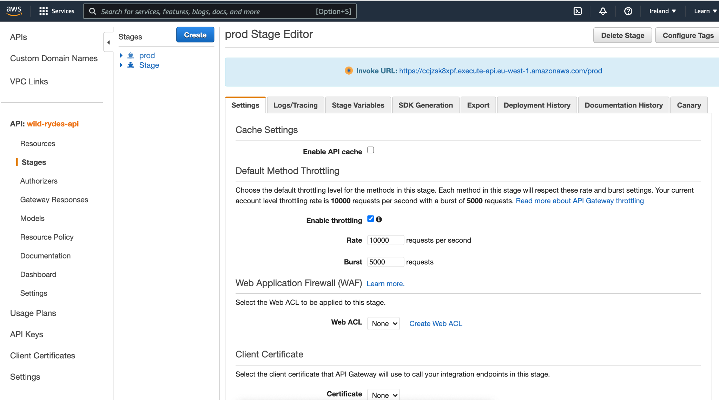

## Verifying the failure for Ireland

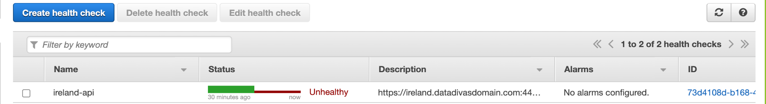

**Checking endpoint on API :**[**https://api.datadivasdomain.com/health**](https://ireland.example.com/health)

*The end point is displaying ap-southeast-1(singapore) as a region when the ireland is unhealthy*

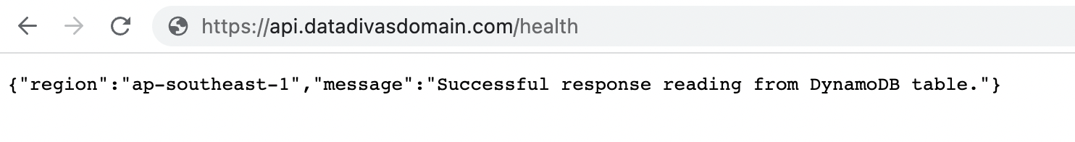

## Verifying the failure for Singapore

*Now Ireland became healthy, and Singapore became unhealthy and the end point is displaying eu-west-1(Ireland) as a region.*

**Checking endpoint on API :**[**https://api.datadivasdomain.com/health**](https://ireland.example.com/health)

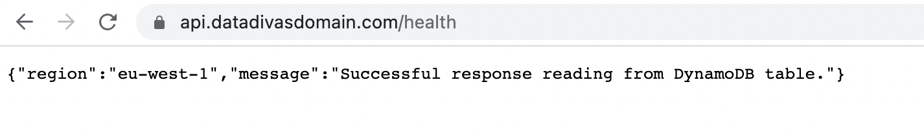

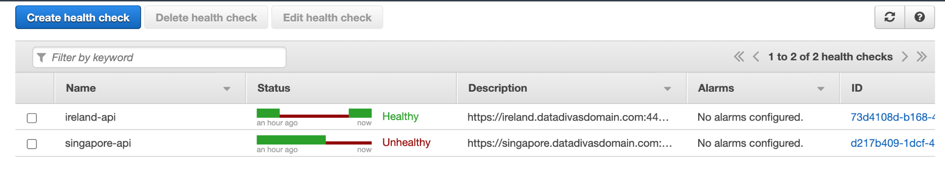

## Creating First Ticket for the Singapore being unhealthy and assigning to EngHwa

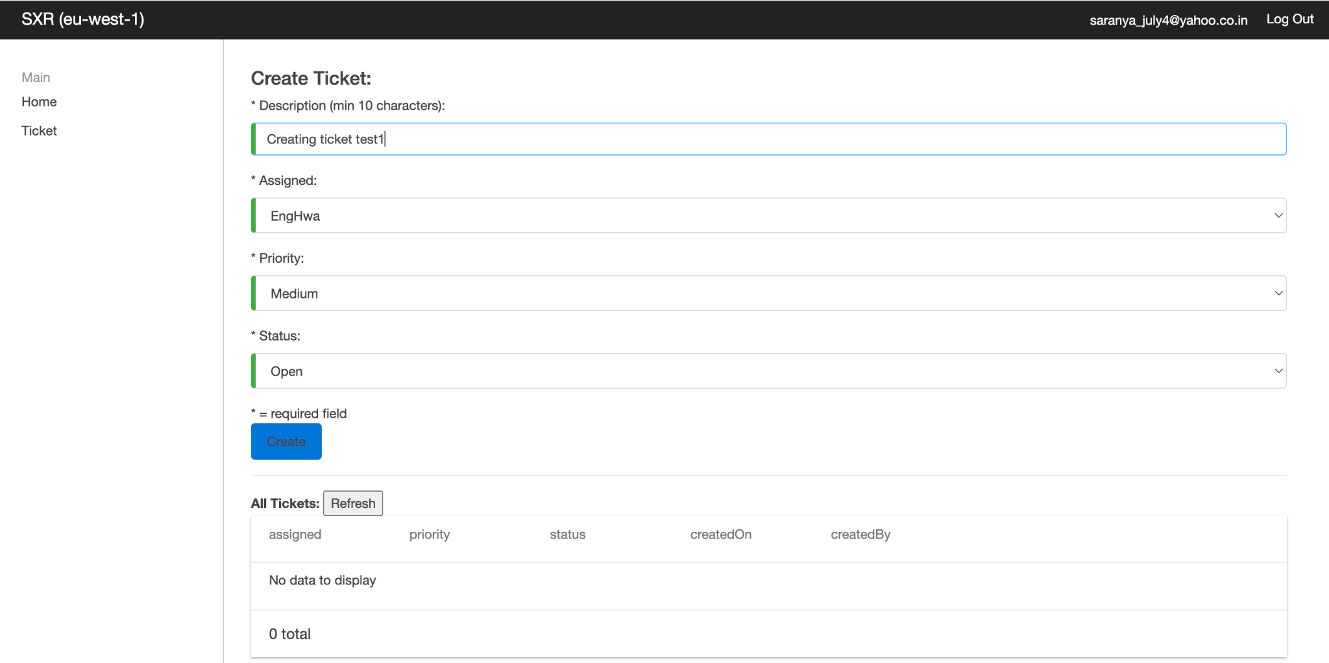

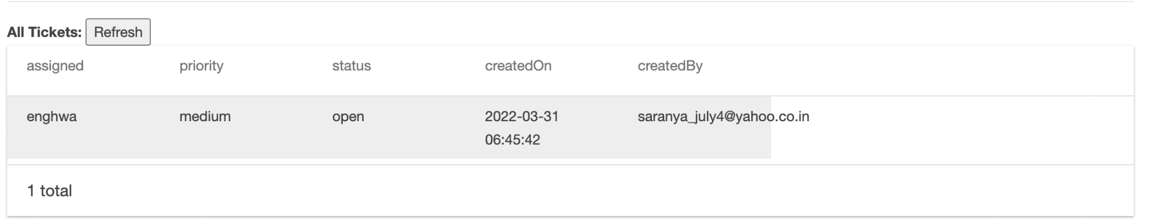

## Verifying the failure for Ireland Again

Now Ireland became unhealthy, and Singapore became Healthy, and the end point is displaying ap-southeast-1(Singapore) as a region.

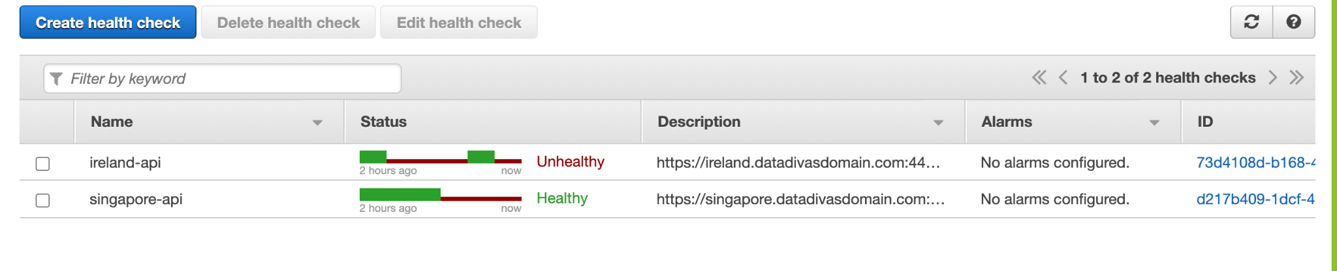

**Checking endpoint on API :**[**https://api.datadivasdomain.com/health**](https://ireland.example.com/health)

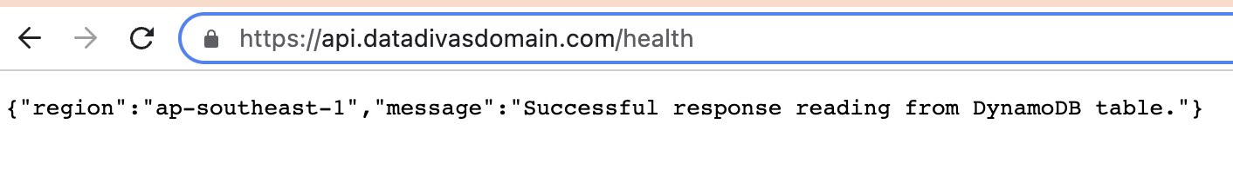

## Creating Second Ticket for the Ireland being unhealthy and assigning to Jay

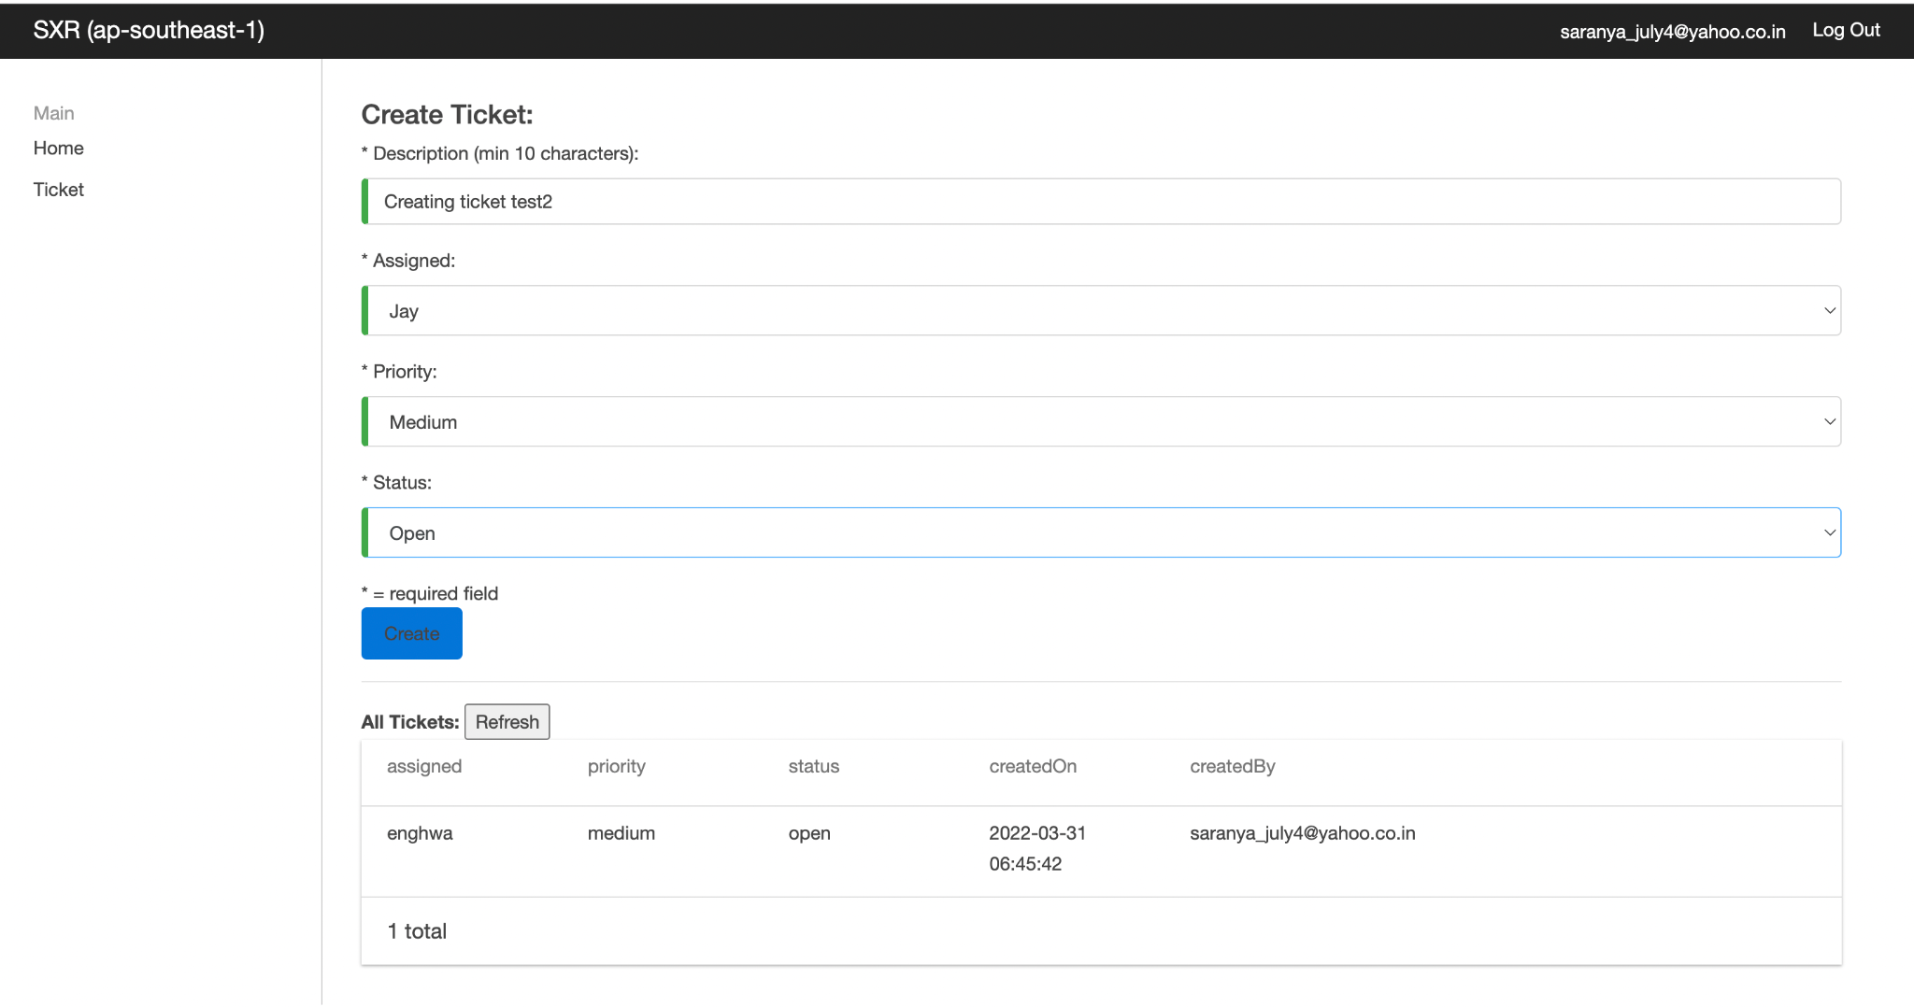

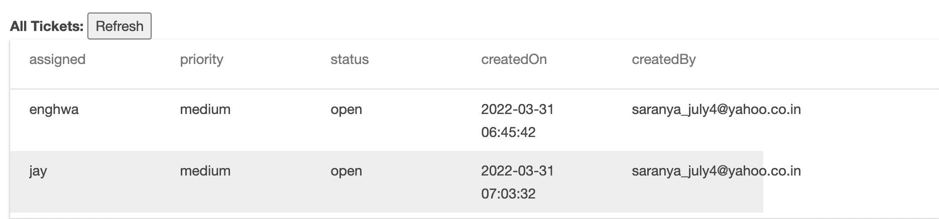

**DynamoDB tables Information in Ireland**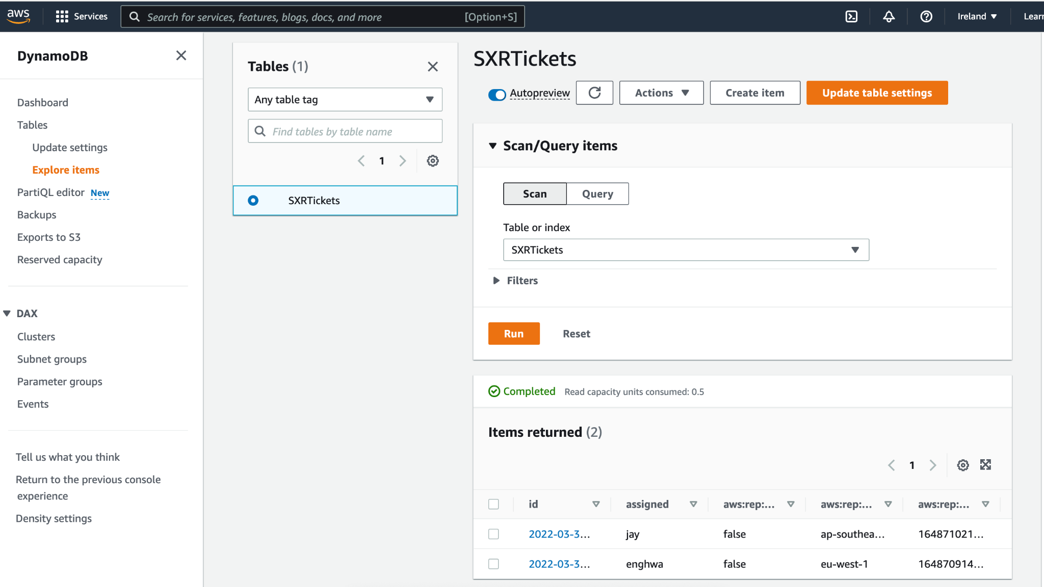

**DynamoDB tables Information in Singapore**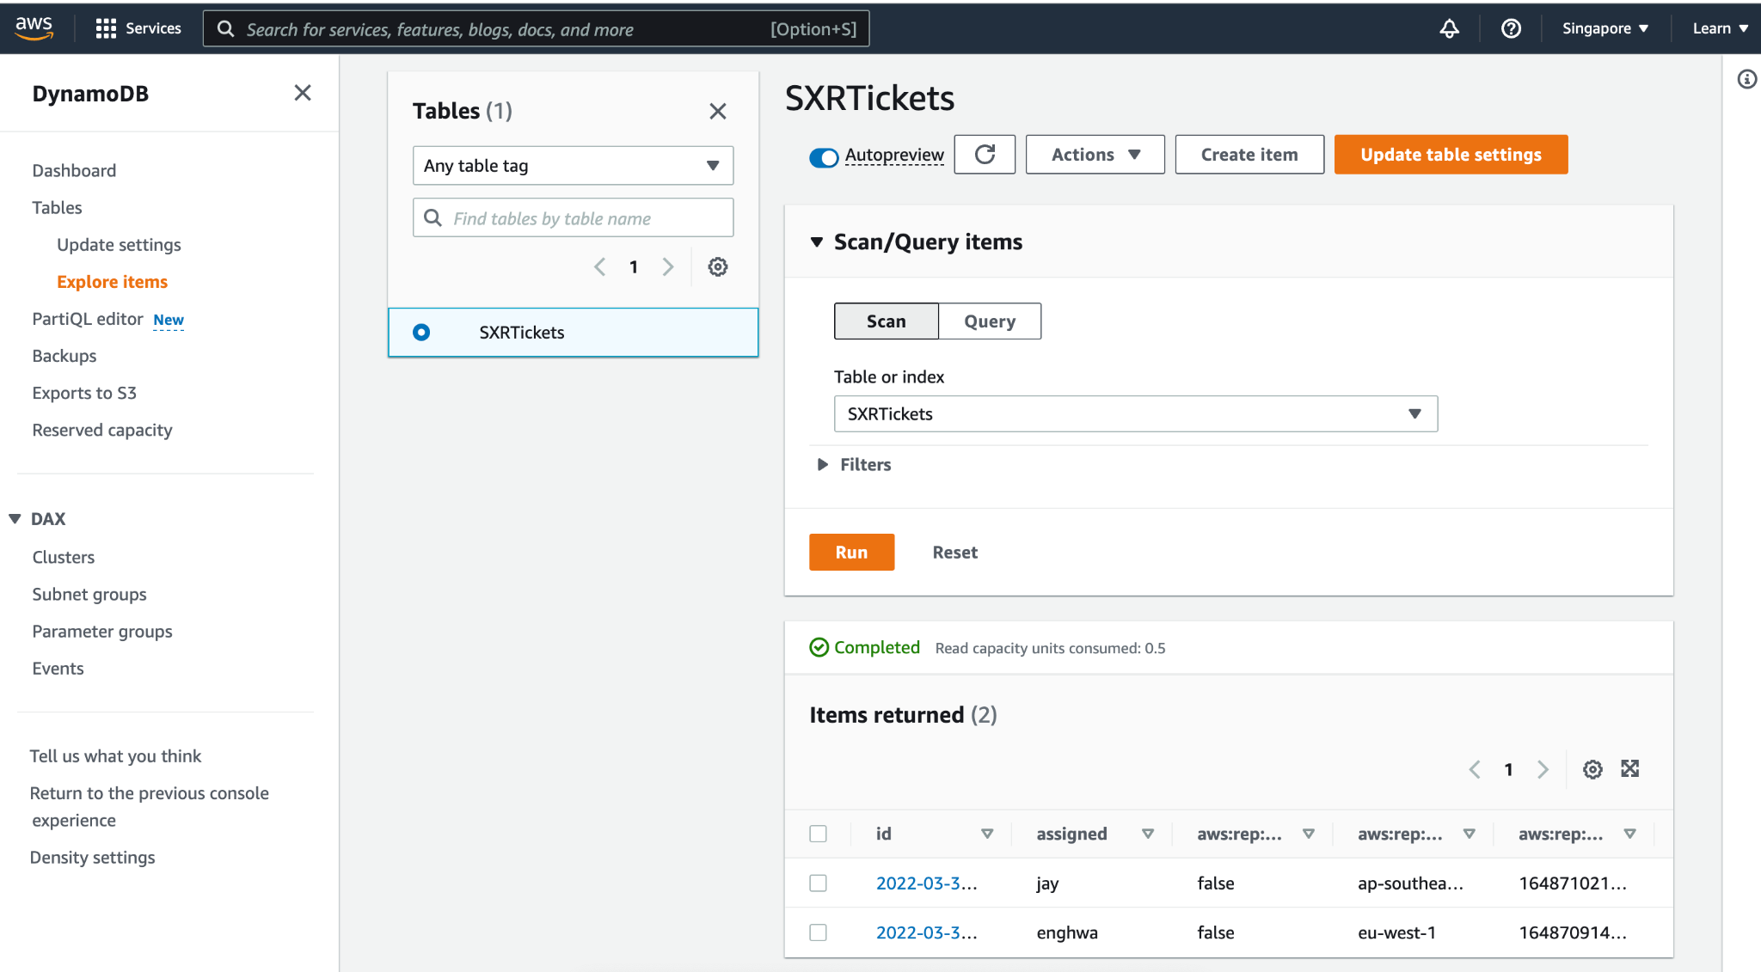

# 7. S3 Replication and CloudFront with Multi-Region S3 Origins

**S3 Cross-Region Replication (CRR)**

## 1.Enable versioning on your source bucket in Ireland region

aws s3api put-bucket-versioning \

--bucket [ticket-service-ui-websitebucket-1v6h833bd5d1y](https://s3.console.aws.amazon.com/s3/buckets/ticket-service-ui-websitebucket-1v6h833bd5d1y?region=eu-west-1)

--versioning-configuration Status=Enabled

## 2.Create a destination bucket and enable versioning on it

aws s3api create-bucket \

--bucket [ticket-service-ui-websitebucket-singapore-1v6h833bd5d1y](https://s3.console.aws.amazon.com/s3/buckets/ticket-service-ui-websitebucket-1v6h833bd5d1y?region=eu-west-1) \

--region ap-southeast-1 \

--create-bucket-configuration LocationConstraint=ap-southeast-1

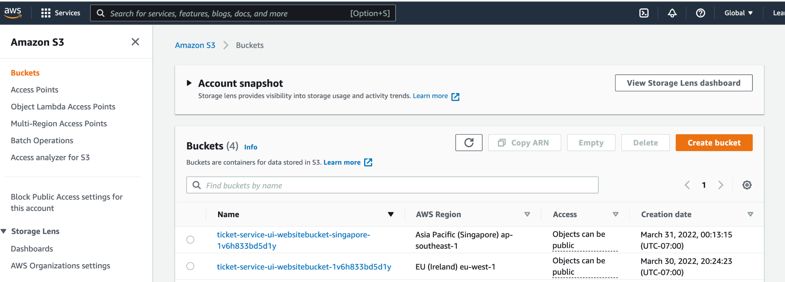

**Enabling Version**

aws s3api put-bucket-versioning \

--bucket [ticket-service-ui-websitebucket-singapore-1v6h833bd5d1y](https://s3.console.aws.amazon.com/s3/buckets/ticket-service-ui-websitebucket-1v6h833bd5d1y?region=eu-west-1) \

--versioning-configuration Status=Enabled

## 3.Create an IAM role

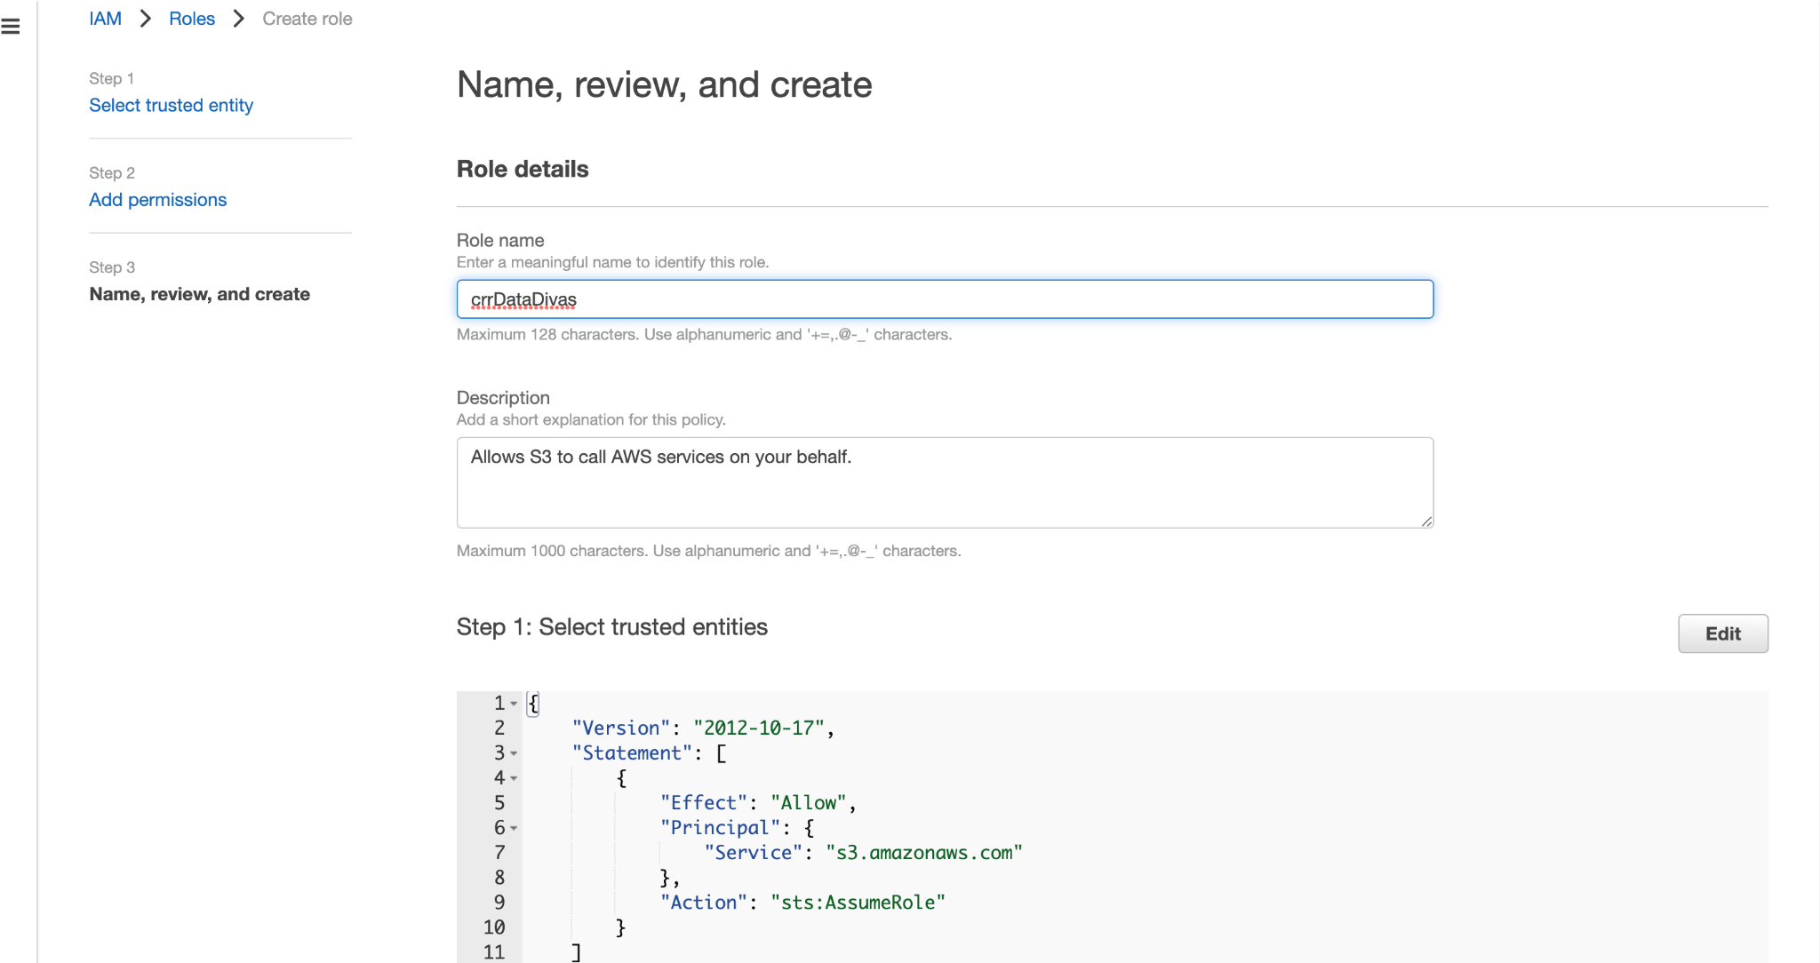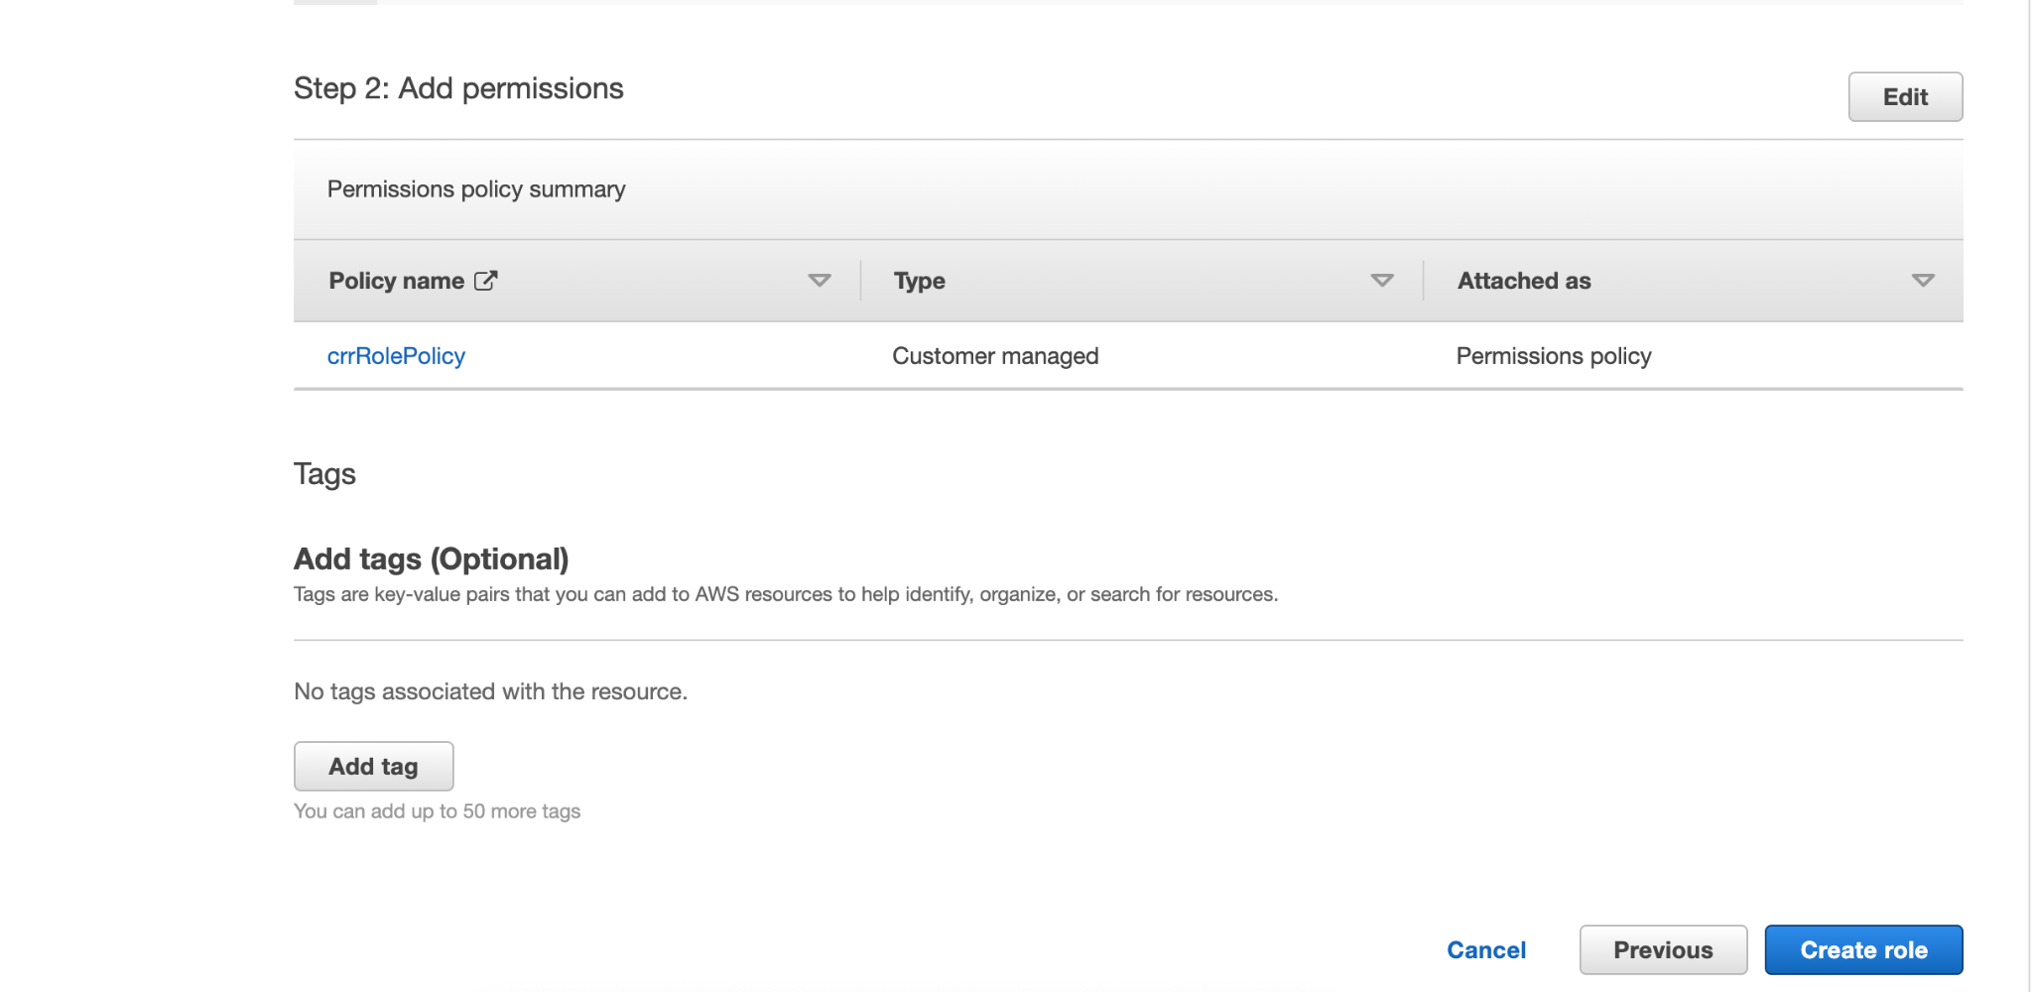

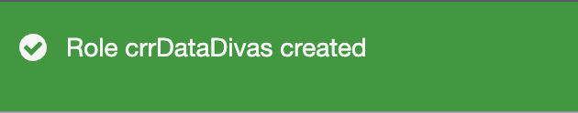

**Replication.json**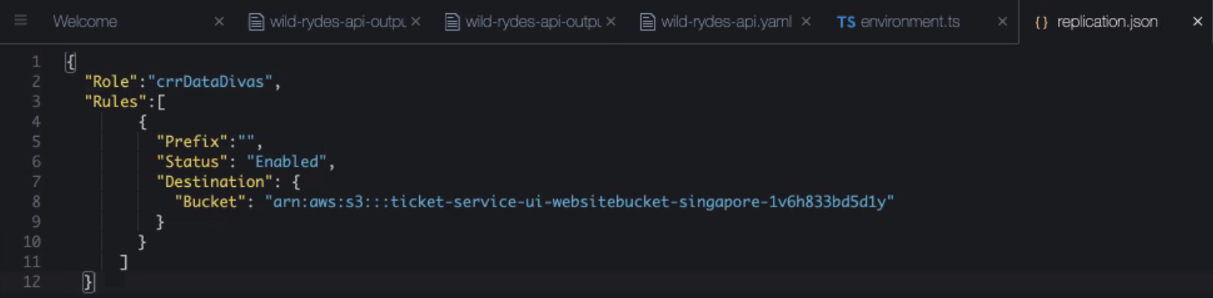

**Running the following command to add the replication configuration to your source bucket.**

aws s3api put-bucket-replication \

--replication-configuration file://replication.json \

--bucket[ticket-service-ui-websitebucket-1v6h833bd5d1y](https://s3.console.aws.amazon.com/s3/buckets/ticket-service-ui-websitebucket-1v6h833bd5d1y?region=eu-west-1)

**Building the App**

aws s3 sync --delete dist/ s3://[ticket-service-ui-websitebucket-1v6h833bd5d1y](https://s3.console.aws.amazon.com/s3/buckets/ticket-service-ui-websitebucket-1v6h833bd5d1y?region=eu-west-1)

**CloudFront Origin Failover**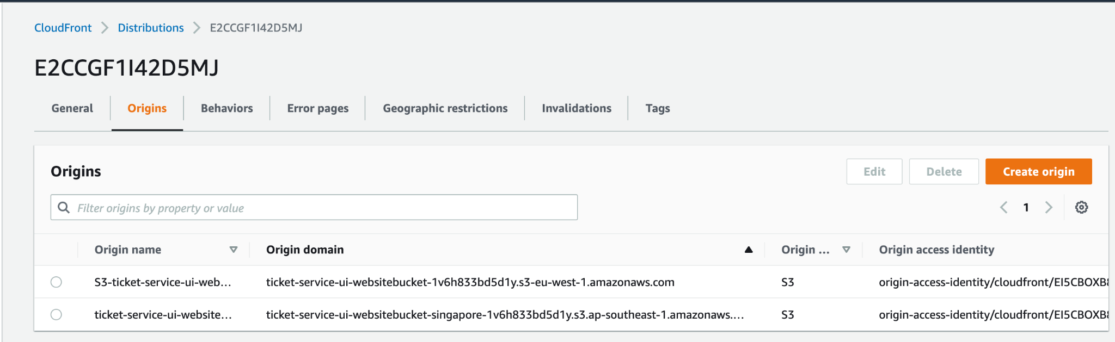

**Create Origin**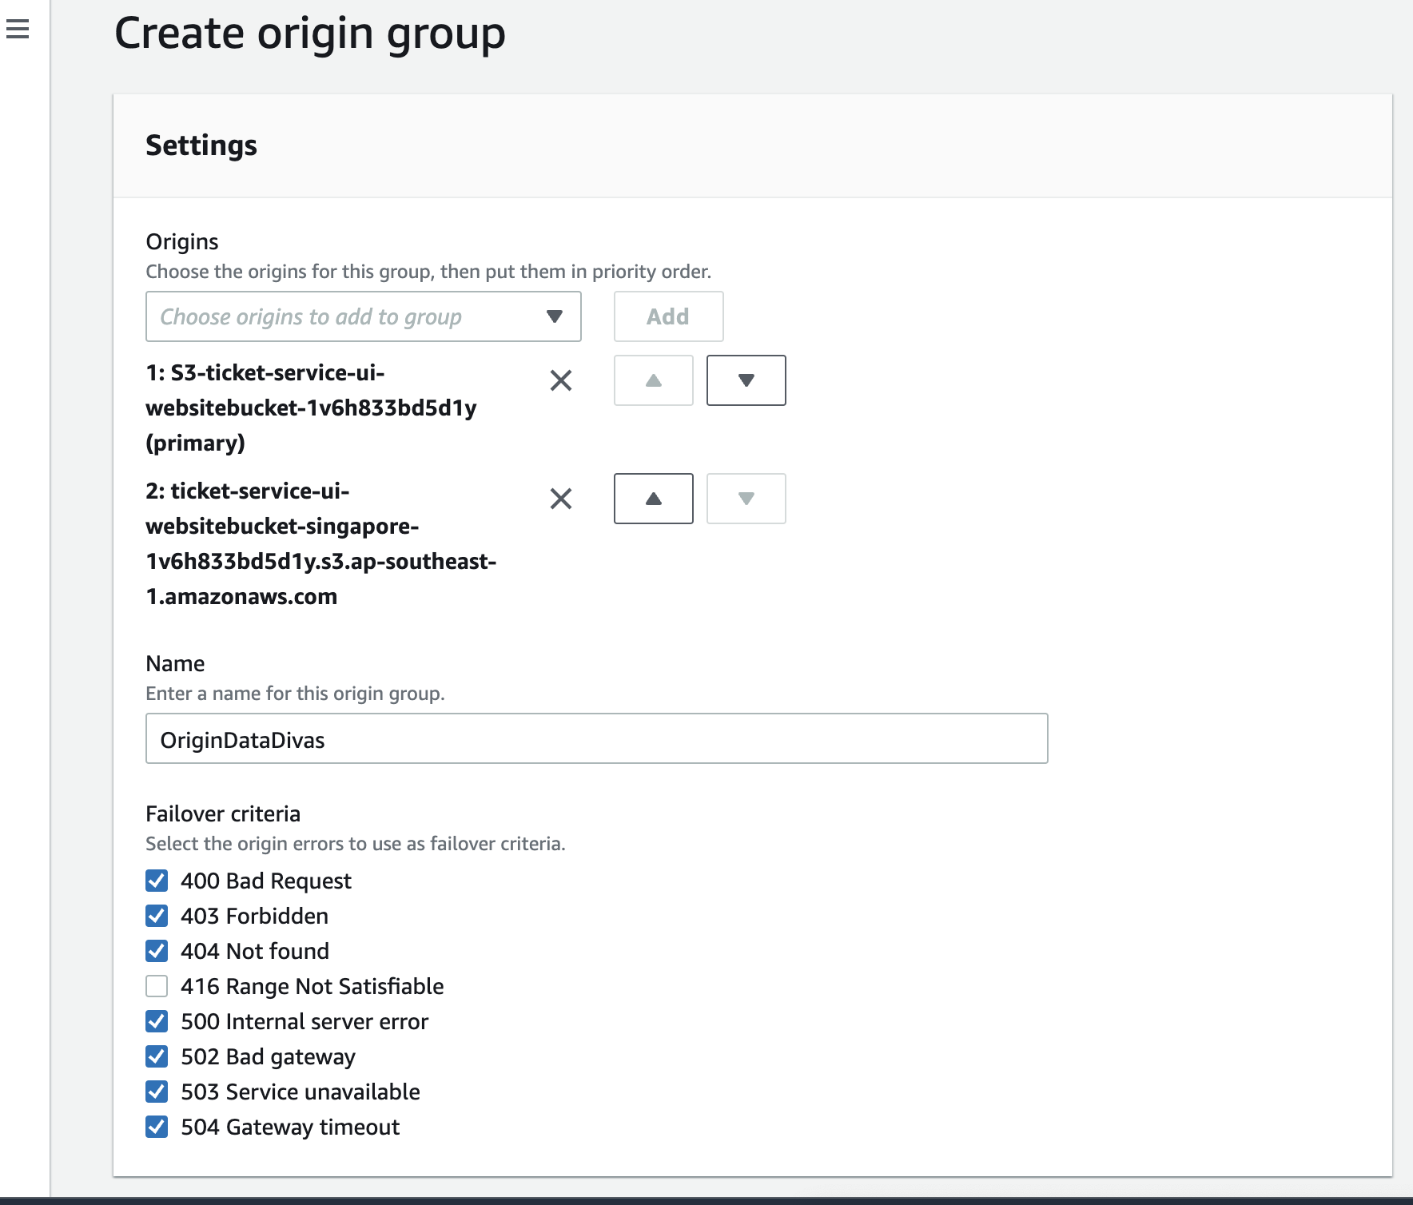

**aws cloudfront create-invalidation --distribution-id** [**E2CCGF1I42D5MJ**](https://us-east-1.console.aws.amazon.com/cloudfront/v3/home?region=us-west-2#/distributions/E2CCGF1I42D5MJ) **--**paths "/images/app-screenshot.png" "/images/app-screenshot2.png"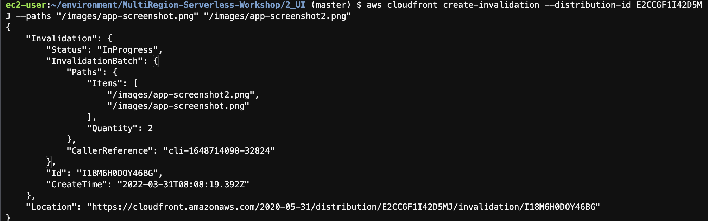

# Test CloudFront Failover

Checking the multi-region active-active ticketing system working perfectly though the primary region (Ireland) has an issue in S3 (Deleted the S3 bucket in the source region)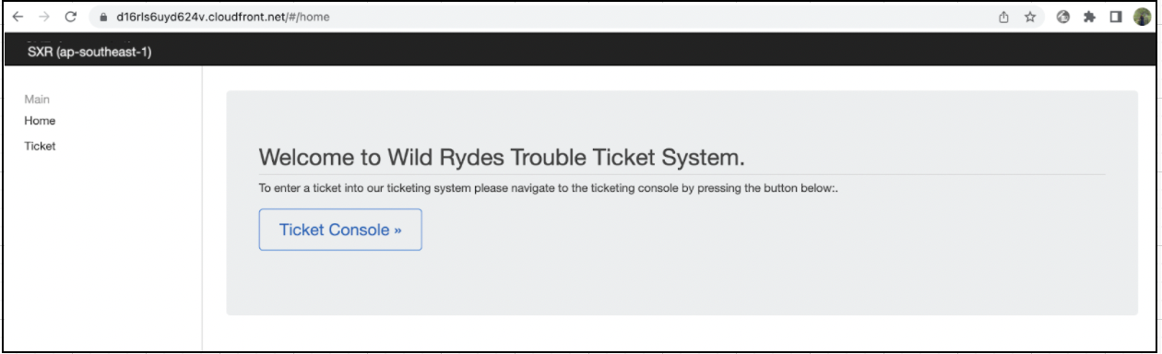

# References

* GitHub - enghwa/MultiRegion-Serverless-Workshop: Build an Active/Active Multi-Region Serverless Application for Resilience and High Availability. GitHub. (2022). Retrieved 31 March 2022, from https://github.com/enghwa/MultiRegion-Serverless-Workshop.